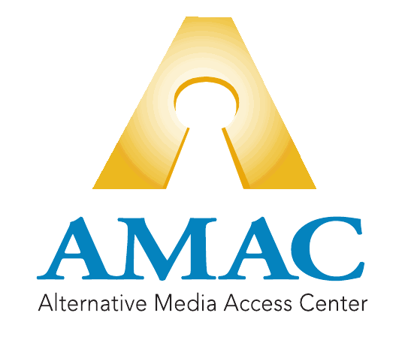

NEON Training Guide

Table of Contents

Signing into NEON 2
Adding a Student 3
Adding an Order 5
Ordering Braille 7
Searching the AMAC Repository 8
Downloading Books 10
Book Quote Calculator & Monthly Invoice Report 11
Training & Support 12

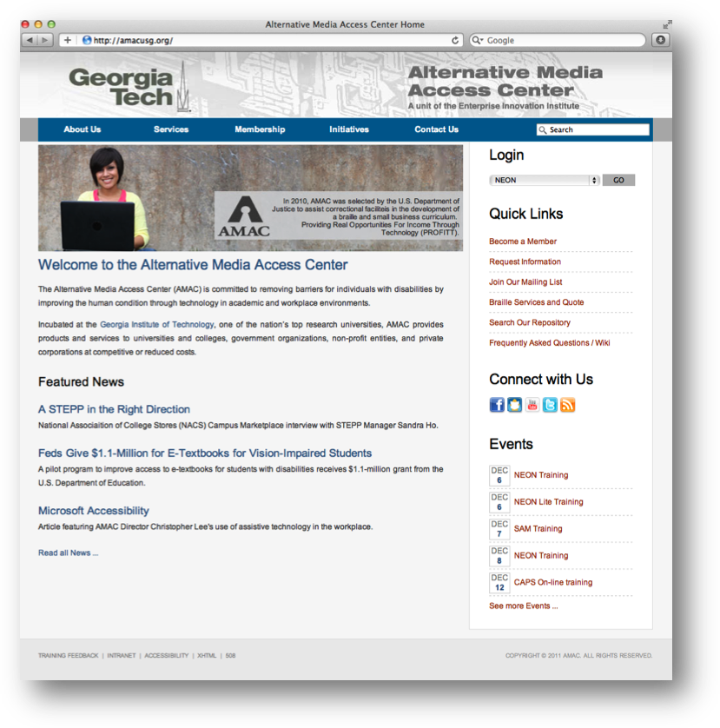 Signing into NEON

- Go to www.amacusg.org
- Select NEON under Login section, then press GO
- Login with unique email and password

Adding a Student
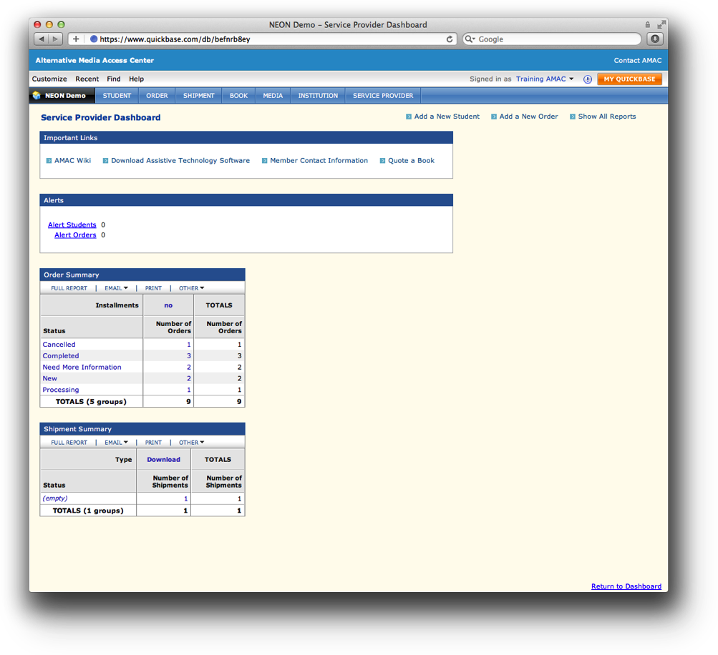
- Click on Add a New Student
- Fill out student information
- Fields marked with asterisk (*) are required

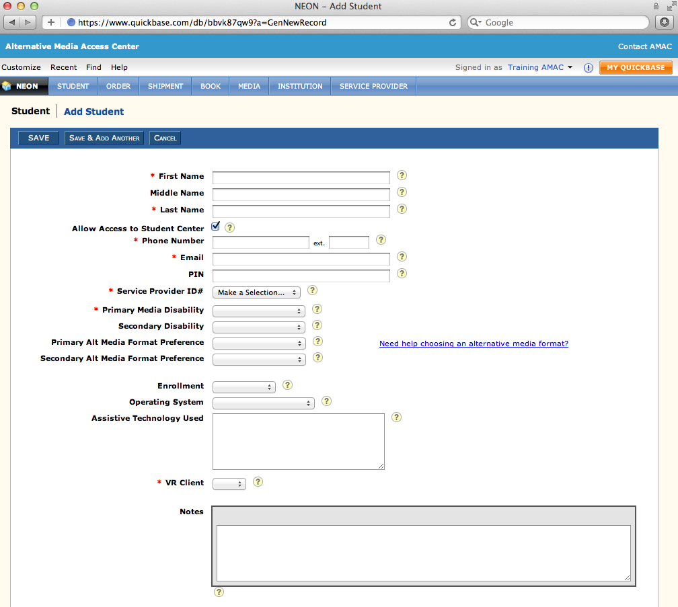
Adding a Student (cont.)
- Uncheck Allow Access Student Center if you do not want student to access books and software themselves
- Email and PIN are used for student logins to Student Download Center
- While not required, specify student’s Primary Alternative Media Preference

Adding an Order
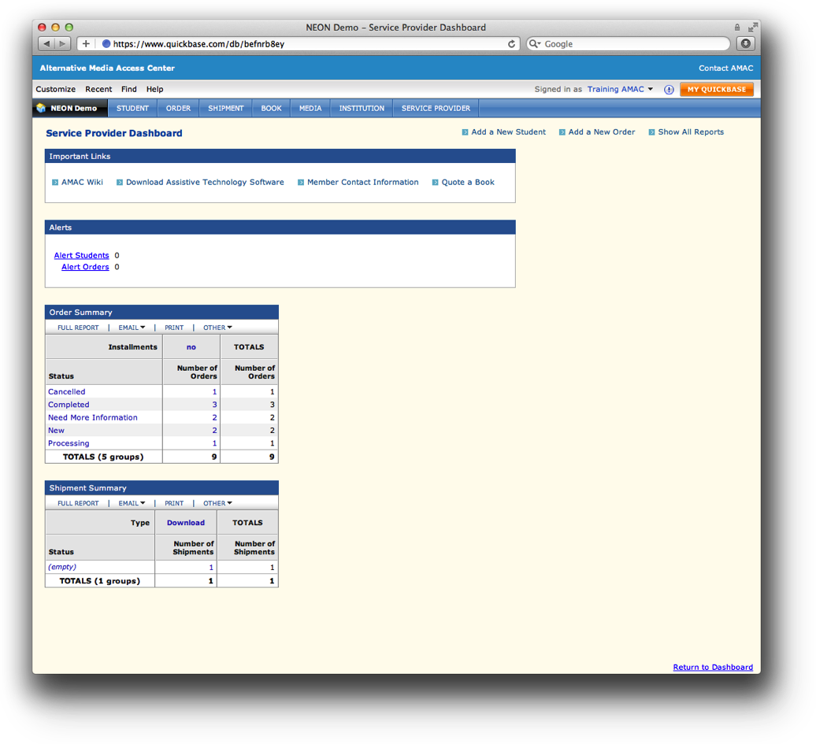
- Click on Add a New Order
- Fill out order information
- Fields marked with asterisk (*) are required

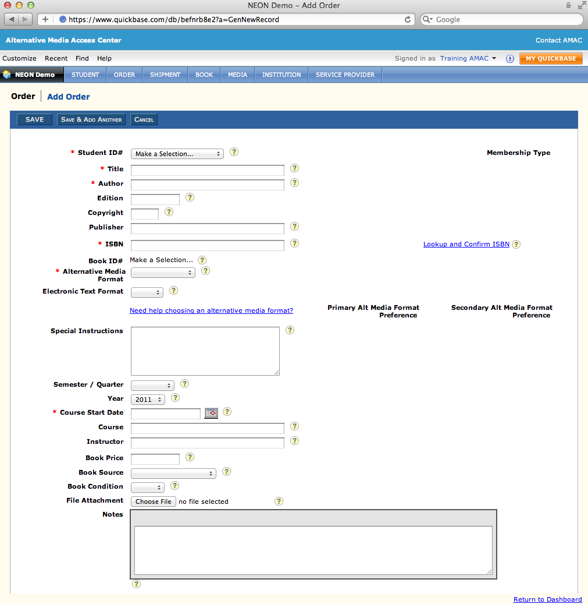
Adding an Order (cont.)
- Select Student ID#
- Fill in required book information (title, author, etc.)
- Input either 10 or 13 digit ISBN
- Select Alternative Media Format – if choosing Electronic Text, select Electronic Text Format (pdf or doc)

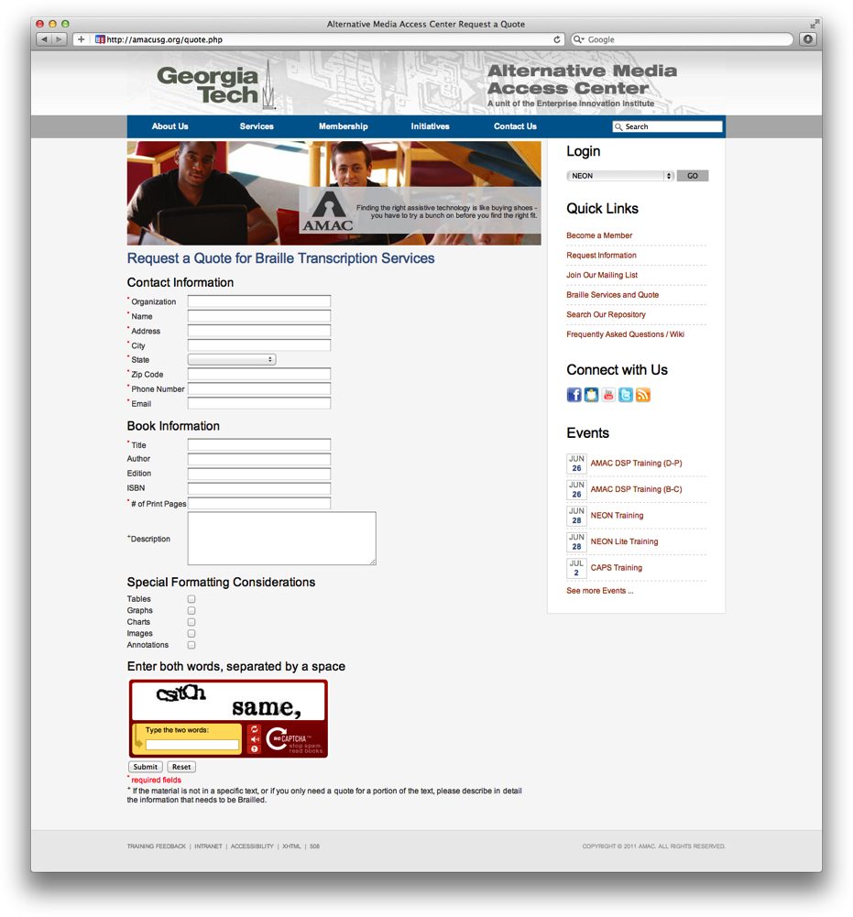 Ordering Braille

- Fill out a Quote request at amacusg.org/quote.php
- Sign and return (fax, email) quote to AMAC
- Add your order in NEON as seen in the pages above

Searching the AMAC Repository
- Click on the grey Find button
- Type in your book’s ISBN, title, or author
- Select In: Book
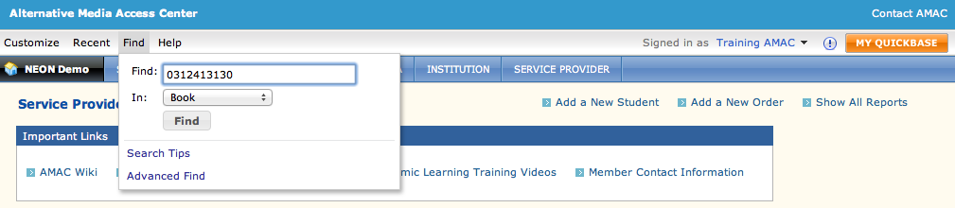
- 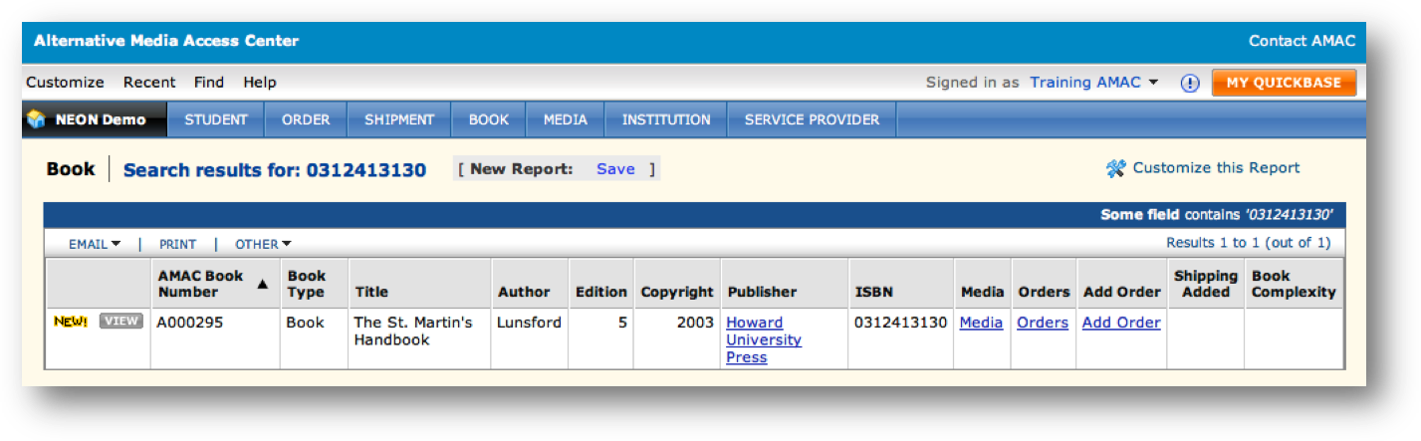If correct book is found, click on the Add Order button
2
1

Downloading Books
- Search for the book order you wish to download (similar to above)
- Click on the grey View button
- Scroll down to the Fulfillment section of the order record
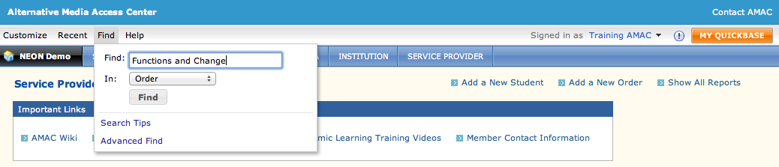
- 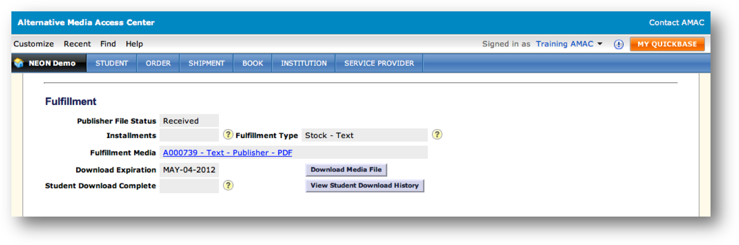Click on the Download Media File button
2
1

Book Quote Calculator & Monthly Invoice Report
- Click on Quote a Book to estimate a book price based off page count and alternative media format
- 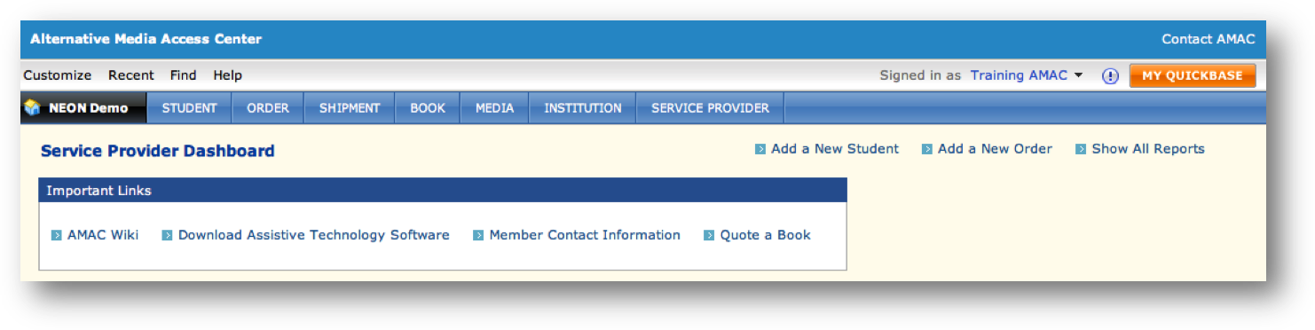Under the Order tab, click on Invoice Billing (FY12) to view the past months’ invoices (Deluxe Members Only)
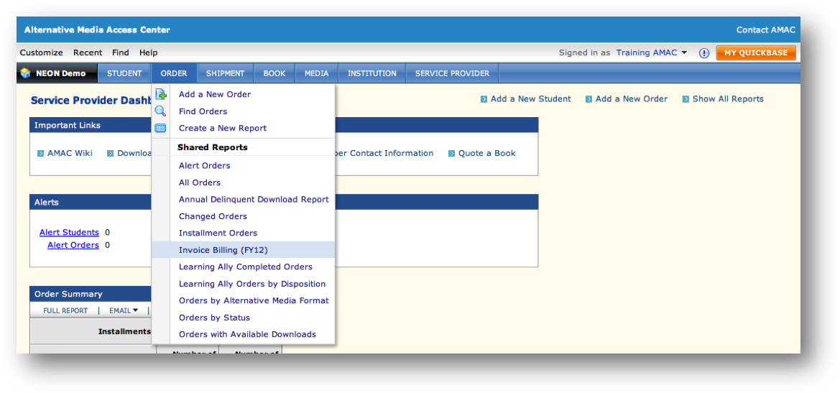

Training & Support
- Click on the grey Help button in NEON, then select NEON Help Center
- Sign up for weekly NEON Trainings on the AMAC Events Webpage (www.amacusg.org/events.php)
- Email AMAC Technical Support at amactech@amac.gatech.edu
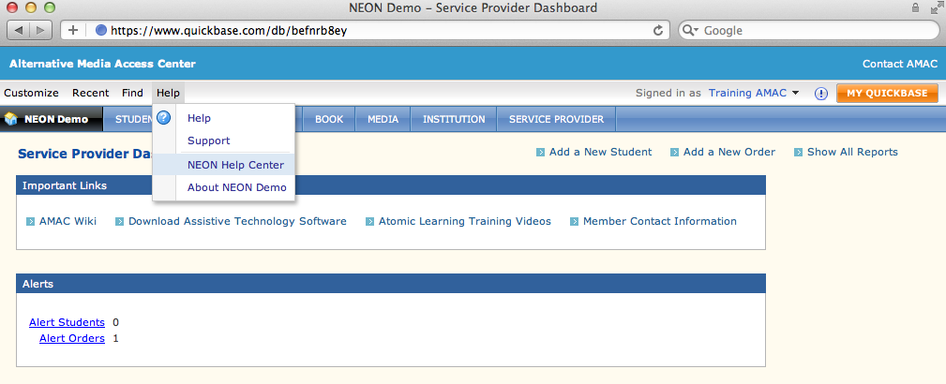
- Call AMAC Technical Support at 1-866-418-2750 (M-F 8:30-4:30 EST)

