

AMAC Orders User Guide

Table of Contents

Signing into AMAC Orders 2

Adding a Student 3

Adding an Order 5

Searching the AMAC Repository 7

Downloading Books 8

Book Quotes and Reports 9

Updating Insitution Information 10

Training and Support……………………………………………..11

# Signing into AMAC Orders

* Go to [www.amacusg.org](http://www.amacusg.org)
* Select **AMAC Orders** under Login section, then press **GO**
* Login with unique email and password

# Adding a Student

* Click on **Add Student**
* Fill out student information
* Fields marked with a red asterisk (*) are required

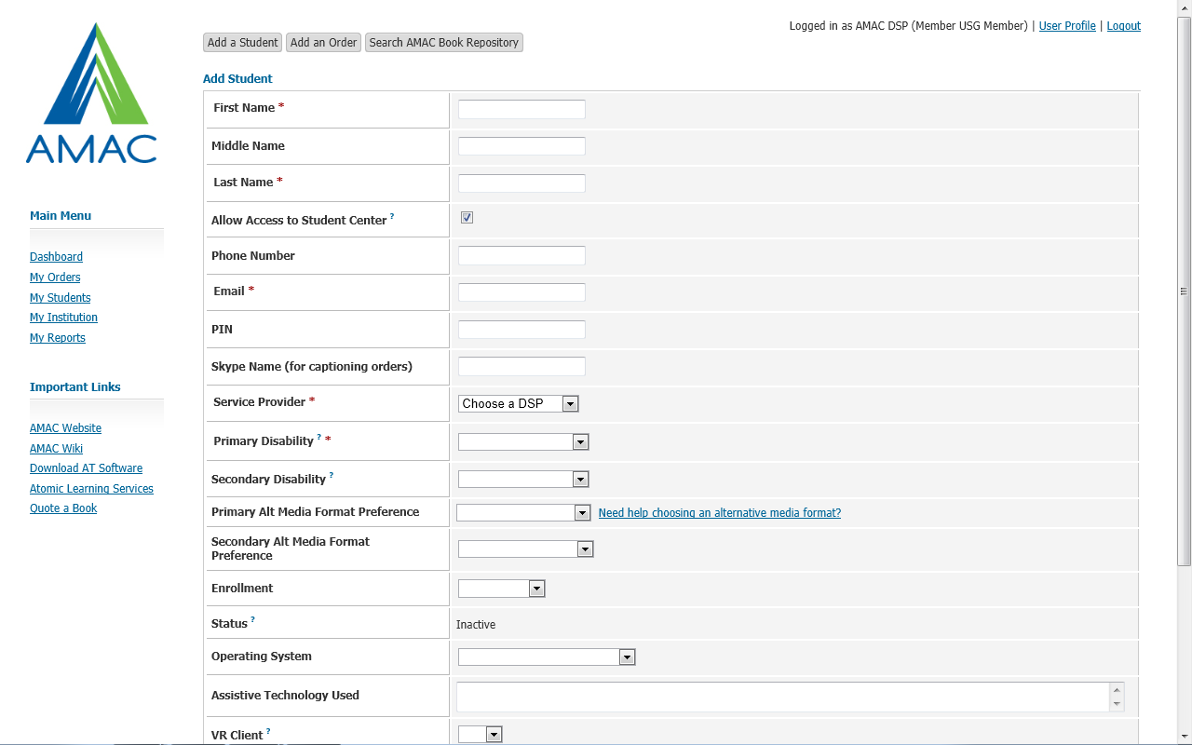**Adding a Student (cont.)**

1. Uncheck **Allow Access Student Center** if you do *not* want student to access books and software themselves
2. **Email** and **PIN** are used t give student access to Student Download Center
3. While not required, specify student’s **Primary Alternative Media Preference** to remind you later what format each student prefers

# 

# 

# Adding an Order

* Click on **Add Order**
* Fill out order information
* Fields marked with a red asterisk (*) are required
* Orders that require your attention are listed under **Alert Orders** in the top right corner of the screen

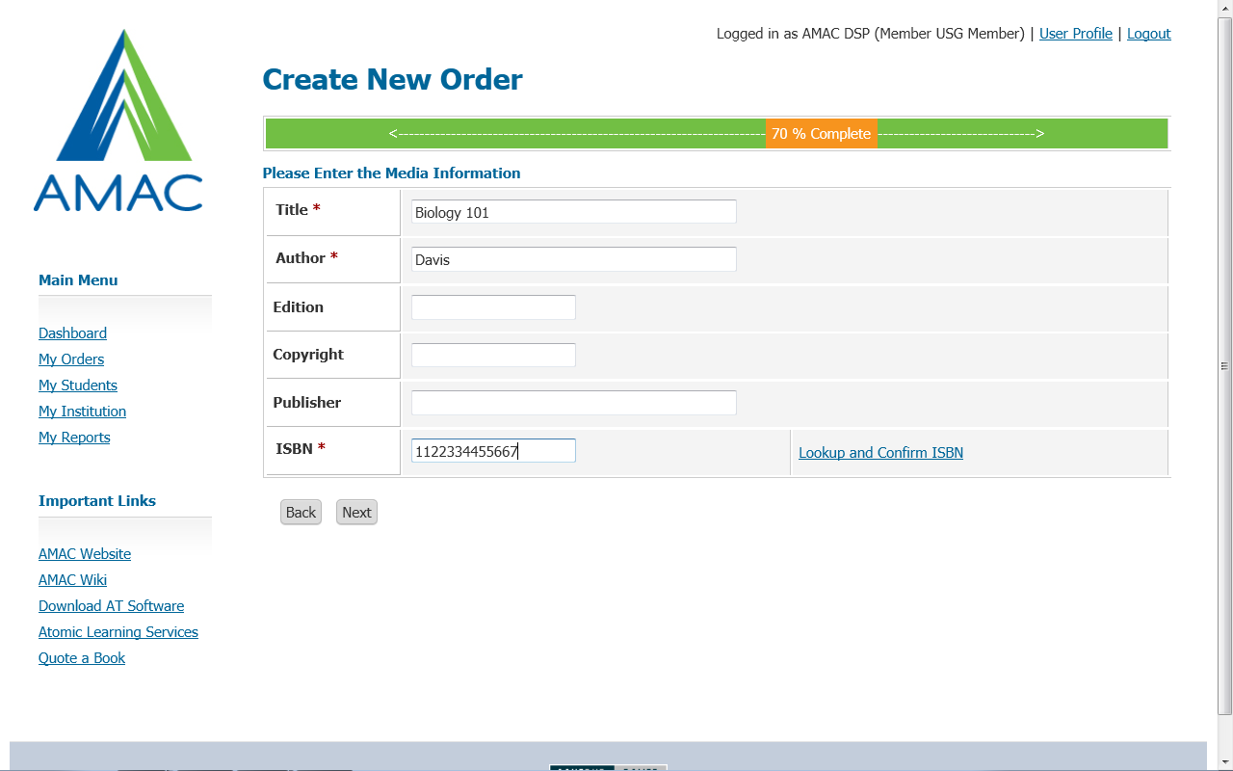

**Adding an Order (cont.)**

1. Select **Student ID#**  and go through the next steps
2. Fill in required book information (title, author, etc.)
3. Input either 10 or 13 digit **ISBN**
4. Click on link to **Look up and Confirm ISBN**
5. Select **Alternative Media Format** – if choosing Electronic Text, select **Electronic Text Format** (PDF, DOC or HTML)
6. You can place orders for E-Text, Captioning, and Braille
7. Review your Order before hitting submit

**Searching the AMAC Repository**

* Click on the Search AMAC Book Respositorybutton
* Type in your book’s ISBN, title, or author
* Click on Search
* 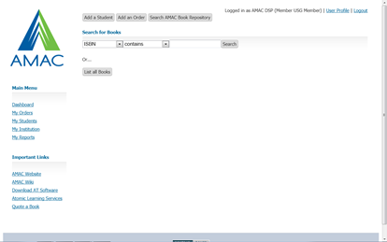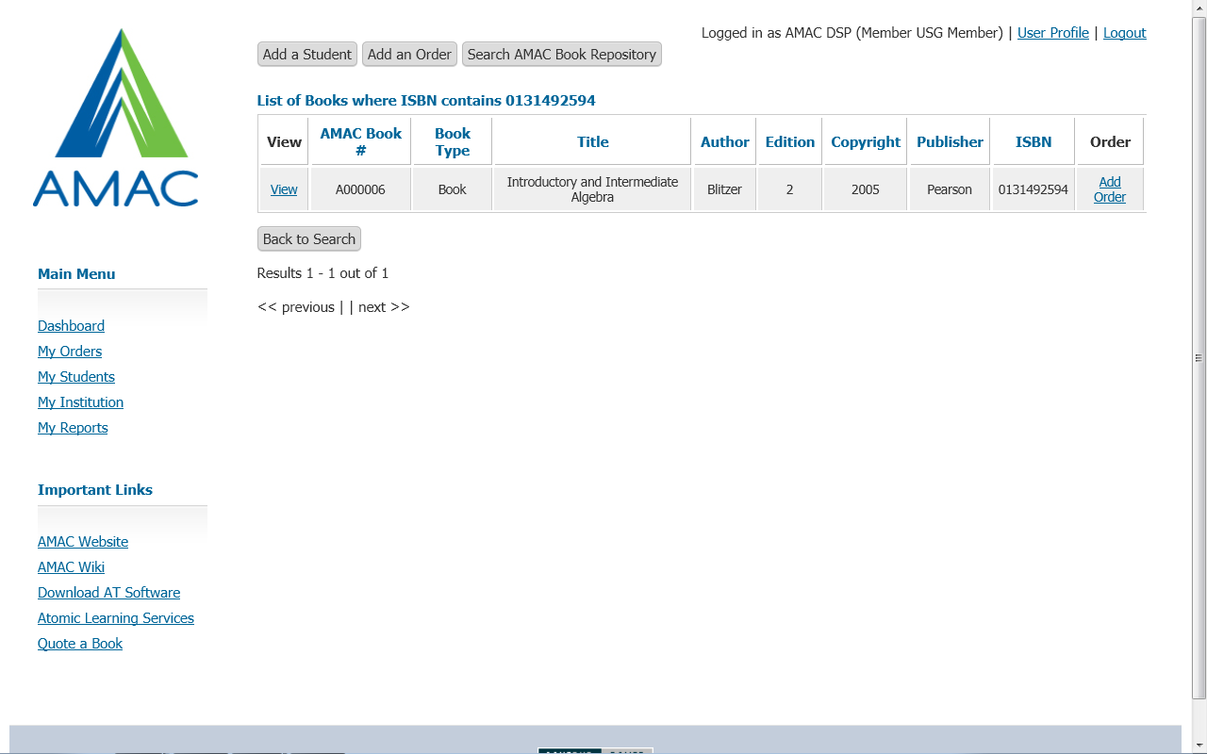If correct book is found, click on the **Add Order** button on right hand side

# 

**Downloading Books**

* Search for the order using the quick link located on the **Main Dashboard**
* Click on the **View** button
* Scroll down to the **Downloads** section of the order record
* Click on the **Download File** button 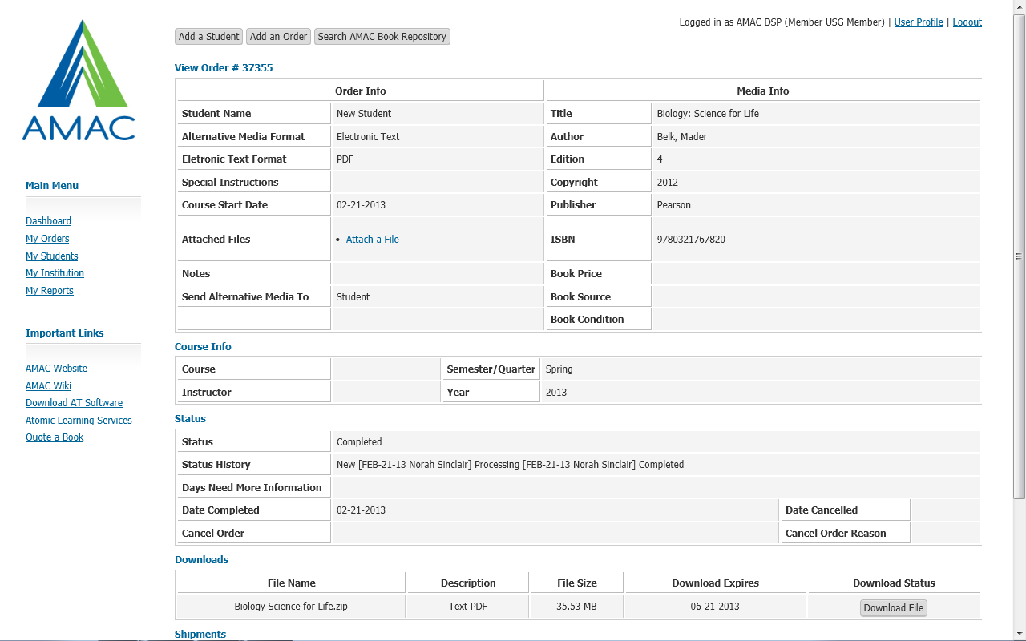

# Book Quotes and Reports

* Click on **Quote a Book** to estimate a book price based off page count and alternative media format
* Click on **My Reports** and see a list of commonly requested reports

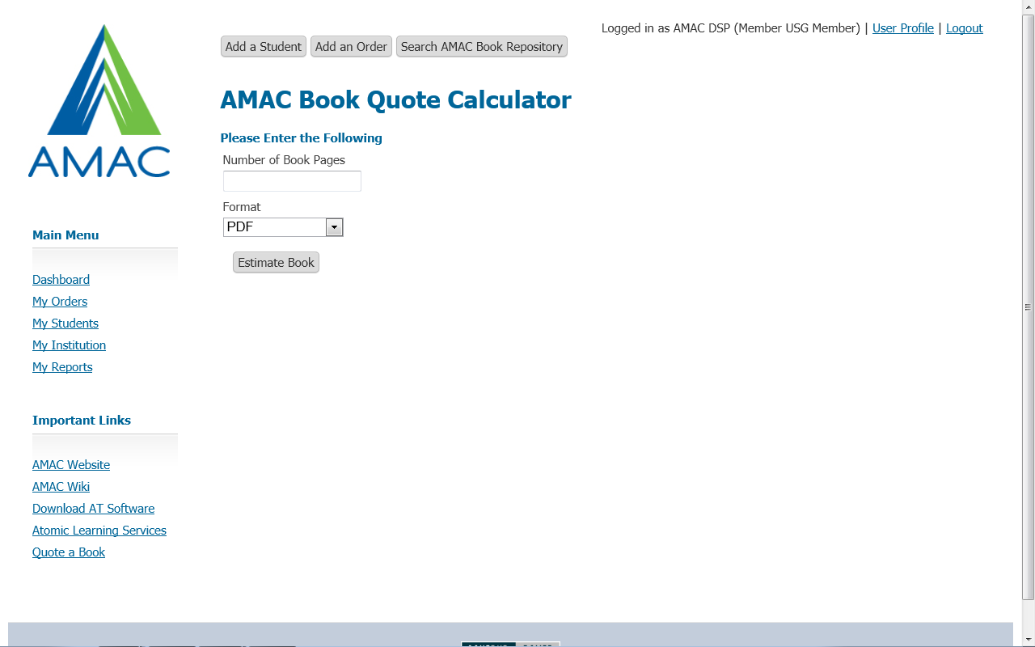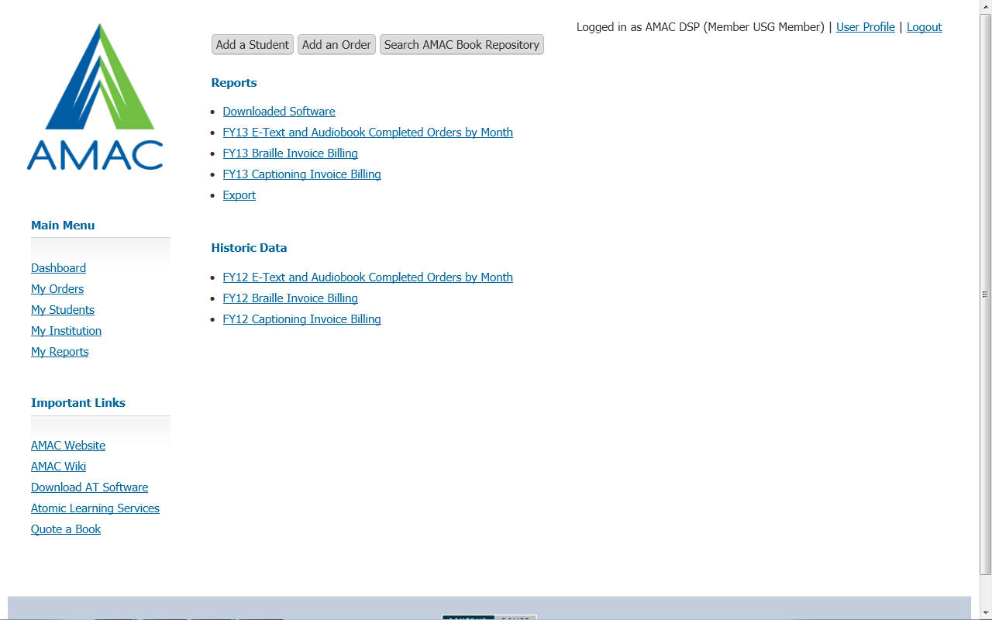

# 

# Updating Institution Information

* Click on **My Institution** on Main Dashboard
* Click to update Contact Information, Add Users, or Remove Users

# Training and Support

# If you would like additional training, sign up for an AMAC Orders training on the AMAC Events Webpage (www.amacusg.org/events.php)

# Email or Call AMAC Technical Support at [amactech@amac.gatech.edu](mailto:amactech@amac.gatech.edu); 1-866-418-2750 (M-F 8:30-4:30 EST)