Using SAM with the new QuickBase

Intuit has released a new version of QuickBase and this change will slightly affect how SAM appears to you. Although the change will eventually be mandatory, Intuit is allowing us to show you how it will look before the change. During this time, you can use both the old and new version. PLEASE use this time to get accustomed with the new SAM and let us know of any problems or concerns you encounter. We will convert SAM to this new version: March 15, 2012. This guide will give an overview of using SAM during the transition.

Switching between versions
Once invited to preview the new QuickBase, a footer should appear at the base of your page.

This is what the footer will look like at the bottom of your main page.

Click on the footer to expand its contents. When you expand this link, you will see a brief description of the changes as well as a link to a PDF providing more detailed information. Click 'Preview the new QuickBase now' (highlighted in bright green) to reveal the new design.

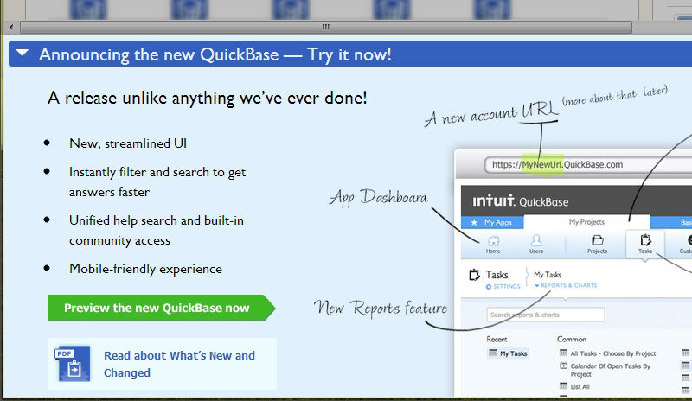
The expanded footer.

Once you are looking at the new SAM, PLEASE notice that the URL of the page has changed. Before you would see: www.quickbase.com. NOW it will read: amacsam.quickbase.com. If at any time you would like to view SAM using the old version, simply change the “amacsam“ portion of the URL to “www” and refresh your browser to make the switch. Re-expand the footer and click "Back to old QuickBase" to achieve the same effect.

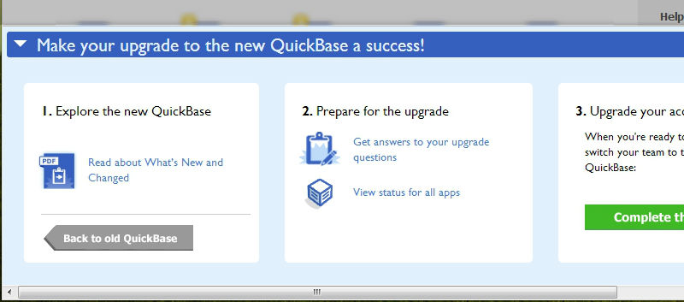
The expanded footer.

Page parts
Once you have SAM opened in the new QuickBase, it's important to note the changes to the page layout. Where before navigation had focused primarily on the application you currently had open (SAM), the new layout splits the navigation into several parts. At the very top of the page, you'll find the Global Bar, which has items pertaining to QuickBase itself. We’ve highlighted this with a gray box with red letters. While just below you'll find the App Bar, which provides tabs to switch between your applications. Below this, the navigation becomes more familiar with the Table Bar, where you'll find links to your various tables. Finally, below this is the Page Bar, where you'll find links pertaining to the current page.

The page header, with the four navigation bars labeled.

Table home pages
One key change in the new SAM is the introduction of table “home” pages. Whereas before clicking on a table (students, disabilities, accommodations, etc.) from the Table Bar would reveal links to add and view records and reports, clicking on a table now will immediately take you to the table's home page. Here, a default report (which can be changed based on roles) lists all records using the default column choices. A panel to the left allows you to quickly filter through the records, while links for reports and creating new records have been moved to the Page Bar at the top.

The Students table home page contains a default report. Links for reports and new students are at the top and filters are in a pane to the left.

In the case that there are too many records to view at once you'll be faced with a search page rather than the default report and filters pane. The area for Reports & Charts will be expanded, giving you the option to simply open a saved report instead.

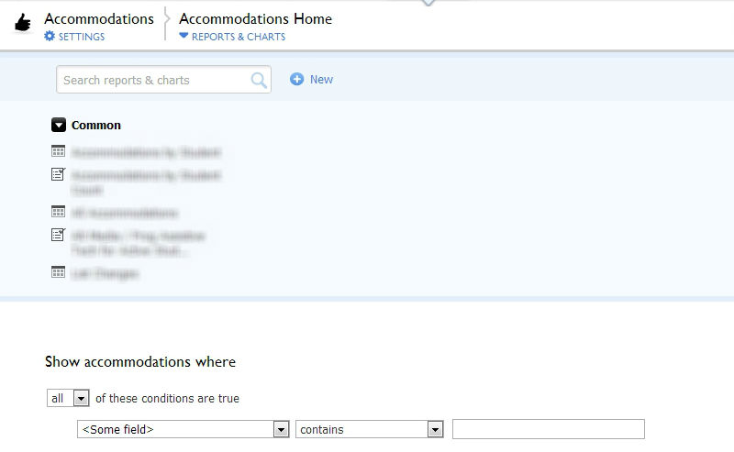
The Accommodations table home page. The Reports & Charts area has been expanded. Below it, search options allow you to filter through accommodations.

Viewing a report
As mentioned earlier, reports are now accessed by clicking the Reports & Charts link in the Page Bar of a table. Once a report is open, you'll notice that the edit and view buttons have been replaced respectively with a pencil and eye icon, while links previously in the header of the table have been moved to the Page Bar. To the right of the More button, a wrench icon now takes the place of the Customize this Report link.

The All Students report within the Students table. Links that have been changed are circled in red.

Viewing records
As was the case when viewing a report, links at the top of a record have been moved to the page bar. The exception to this is the link to return to the report (previously labeled Done) and the link to go the next record. In addition, although these links had previously appeared at the bottom of the record as well as the top, they've been omitted with the update.

The Return and Next links at the upper right side of a record.

The Copy This link, which was also at the bottom, can now been found under the More button in the Page Bar.
The link to copy the record, found under More in the Page Bar.

For records with section headings, clicking on the arrow next to the heading will now allow you to minimize the area.

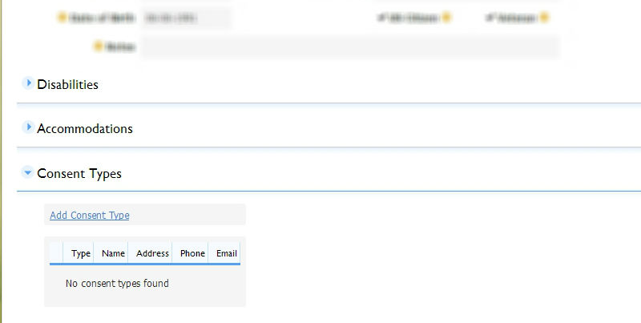
A record with some of its sections minimized.

To add a new student, you’ll simply select the green “+ New Student” rather than select the
“Student” table and from the drop down list select “add student”.

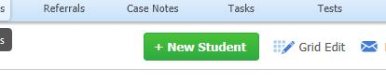
The + New Student link at the upper right side of a record.

We are here to support you as you support students with disabilities!
Do not hesitate to call us if you have any questions during this process: 866-279-2964
REMEMBER: We’ll go “LIVE” on this new SAM, March 15 2013
The SAM team at AMAC

