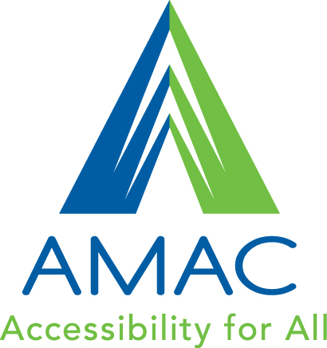

File Format Screening Tool
Questions for Disability Service Providers to consider when deciding which AMAC file format(s) – Braille, Audio on CD, PDF or DOC – to request for their students

About the student

- Does the student have a file preference?
The most important factor in alternative media file format selection is the student’s file preference. When a student requests a specific file format, the format should be
compatible with the student’s available software and hardware and appropriate for the type of textbook.

- What is the student’s print-related disability?
Depending on their disability or disabilities, students will find that certain file formats meet their needs better than others. Students who are blind or have low vision may prefer Braille or an audio format, while students with learning disabilities may prefer e-text or audio. However, knowing the student’s disability can help you begin narrowing down the decision of an appropriate file format, but it should not be the end of the decision process.

- Does the student have proficiencies with a specific format (e.g., how to read Braille)?
Confirm that a student can use a particular format before making a request for that format. For example, not all blind students are able to read Braille or want all of their textbooks in Braille. Or, students may not have the inclination or time at the beginning of their college career to learn new software, but they may be interested in receiving training to use a new file format, software, and/or hardware for the following semester.

- What is the student’s learning style – tactile, auditory, visual, or multimodal?
How a student prefers to interact with text influences which file format will best serve their needs. Maintaining images within the text may be more important to visual learners, while auditory learners learn more efficiently by hearing the text read aloud. Students with combined learning styles will appreciate simultaneously being able to read, hear, and control the text

About the software
- What is the student’s past experience with assistive technology?
Software or hardware know-how or preference can determine which file format to choose for each textbook. If a student is already familiar with using specific text-to-speech software, then consider ordering file formats that are compatible with that software. Learning to use new software may be difficult and should be thoughtfully planned in order to minimize the student’s stress and reduce the possibility of technology abandonment.

- Is the student computer savvy?
How comfortable and proficient a student is at using a computer, downloading books, and using software can influence which file formats to order for them. For instance, if a student has used audio CDs from Learning Ally in the past and is not comfortable navigating an e-text file, you may want to wait teaching them how to use the AMAC student download center and e-text.

- Could the student easily learn new software?
Similar to the considerations you make about your students’ levels of proficiency with computers, also consider their levels of comfort and the timing of learning new software. Waiting a semester or two before teaching them new software may make the most sense in some students’ situations.

- Does the student have any physical, visual, or auditory impairment that would influence their use of certain software or hardware?
Depending on the abilities of your students, certain software or hardware may not be compatible with their needs. For example, students with low vision may appreciate the ability to magnify text and increase color contrast on the computer screen with e-text.
- Does the student need extensive navigation capability within the text?
Depending on how a student intends to use his or her alternate text, consider the navigation capabilities of each file format. For example, if a student intends to use his or her text on a laptop in class, PDF’s allow for exact page layout and navigation that will make it easier for the student to follow along with the rest of the class.

- Does the student need support for note-taking, highlighting, and summary capabilities?
Certain software that read PDF’s often have other features that aid in a student’s learning. Students with learning disabilities may find the note-taking, highlighting, and summary capabilities in e-text, text-to-speech software helpful.

About the textbook

- Do images in the book carry critical information to understanding the concepts being taught or relayed?
If images are critical to understanding the subject, and there is no text to support or describe the images in the book, then PDF’s that display the formatting and images exactly as they appear in the book are best for the student.
- Will the student read the text straight through (e.g., history or literature), or does it contain complex formatting (e.g., science or math)?
Students may find it easier and more convenient to listen to text read to them in audio format for a subject like history or
literature. For subjects like science or math, where seeing the text and equations, highlighting and defining key words, and interpreting figures, graphs, and diagrams is critical, e-text may be a preferable format.

- Does the student use a screen reader (e.g., JAWS or NVDA) to access the textbook?
Students that use screen readers benefit from DOC’s that have been tailored to include a single-column layout, heading levels, and alternative text on images. Additionally, audio on CD’s provide human-read audio descriptions easily navigated with screen reader-friendly software.

For more detailed information on available file formats, visit the Alternative Media Formats page on the AMAC Wiki.

