Tips for a More Accessible MS Word Doc
Documents that are designed using accessibility standards and guidelines are beneficial for all users. Accessibility considerations include: document structure and navigation, alternative text descriptions, accurate reading order, and appropriate color and contrast. Digital content accessibility guidelines are very similar to the guidelines and standards for ensuring web content is accessible, however the techniques to achieve accessibility will vary depending on the format of the document. A key technique for creating more accessible Microsoft Word documents is to create document structure and navigation by using Styles to format Headings.
Use Styles and Headings to add document structure
Adding headings and subheadings (Heading 1, Heading 2, Heading 3, etc.) in a logical order will assist all users in navigating and finding information. Headings will be visibly identified in the body of the document by their formatting, but are also viewable and can aid navigation in the Navigation pane.
To View the Navigation Pane:
In Word 2010, on the Word Ribbon, go to View tab and click the checkbox by Navigation Pane in the Show group. (In Word 2007 click, show Document Map)

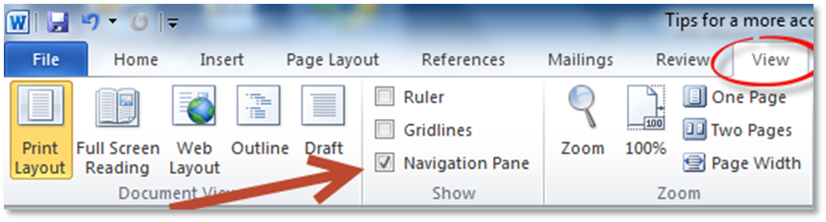

Use Styles to create headings
Using Styles rather than direct formatting has a number of advantages including creating document structure and enabling more efficient updating and revisions. By default, text in the Word Doc will have the Style of Normal.
To apply a Heading style, select text to become heading, in the Home tab, go to the Styles group to apply Heading 1, Heading 2, or Heading 3. (Always begin with Heading 1 and add additional subheadings in a logical order. Skipping a heading level can cause confusion and additional problems, including invalid document form, especially if the document will be exported to another format.)
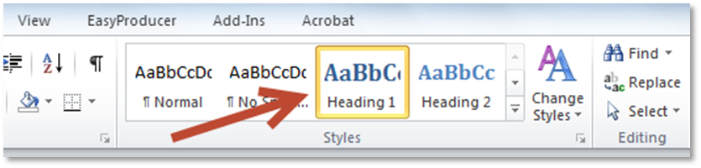
Heading Styles are preformatted. The preset formatting can easily be changed by changing the Style Set. Go to Change Styles > select Style Set and choose a set from the menu or customize the settings by right-clicking the Heading and selecting Modify.
For longer documents, Headings can be used to create linked Table of Contents.
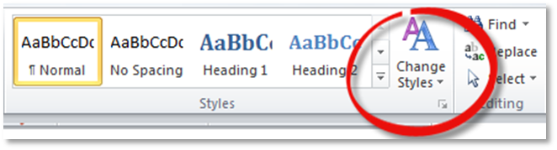
Add alt text to images
Add alternative text descriptions (alt text) to all meaningful images. To determine whether an image needs alt text, determine the purpose of the image. Is it informational or decorative? If the purpose of the image is to convey information or meaning, determine what information the image is conveying and write a short, concise text description that will convey that information. Use complete sentences with proper punctuation when writing alt text descriptions. Avoid using abbreviations or acronyms unless they have been previously defined. Do not duplicate information present in a caption.
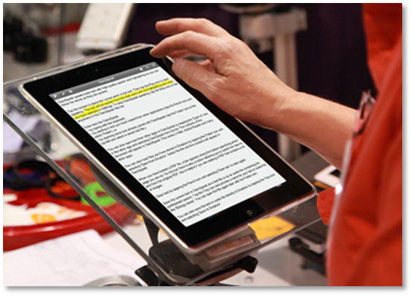
To add alt text to an image in MS Word document:
Right-click the image
Select Format Picture
Select the Alt Text option from the list
Add summary alt text in the description entry area
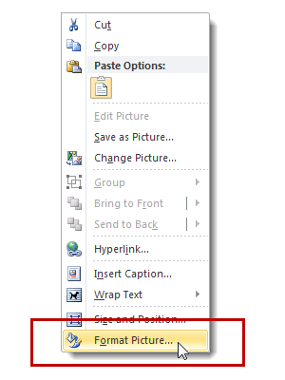
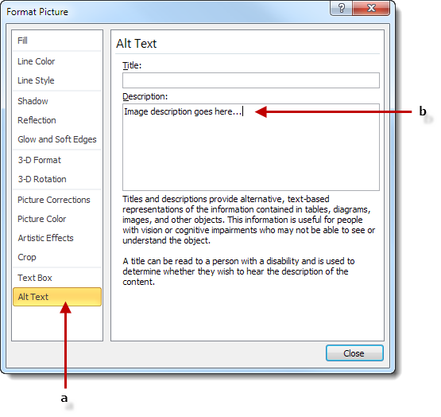
Use list styles for numbered or bulleted lists
Using list styles will identify to a screen reader that there is a list and the number of items in the list. Using list styles will also preserve list formatting when exporting a file to another format.
Item one
Item two
Item three
Highlight list items, go to the Paragraph styles group on the Home tab, and select numbered or bulleted list.
Use table styles
Using table styles helps ensure appropriate table structure with adequate headings and helps preserve logical reading order.
To add a table with headings:
Go to Insert tab on Word ribbon
In the Tables section, select the Tables icon
Select the number of rows and columns for your table
Select the inserted table by clicking its border. When the table is selected, the Table Tools menu will appear
Click on Table Tools > Design
In the Table Styles Options group, select the Header Row check box
Click on Table Tools > Layout and be sure to click on Repeat Header Rows
Add alt text to tables

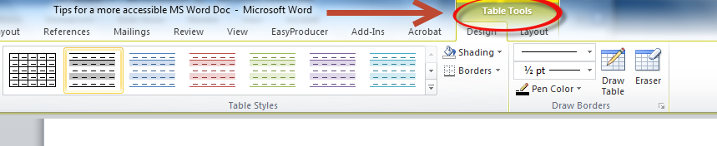
Table 1 Sample Table
ID | Institution | Membership type | Status
12 | University 12 | Basic | Active
22 | University 22 | Basic | Active
42 | University 42 | Basic | Active

Add alt text summary description
Adding an alt text summary description provides users of screen readers the ability to gain the same type of summary information that sighted users can obtain by quickly browsing a table. Right click table > select Table Properties > Alt Text
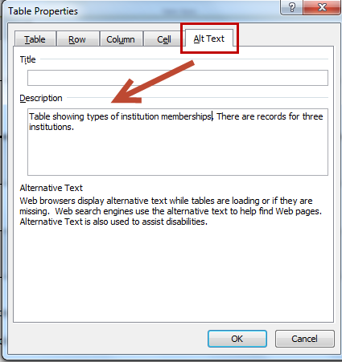
Use a simple table structure and tab through the table to check the reading order.
Hyperlinks with context
It is a best practice to create meaningful text for hyperlinks. Do not use links such as “click here” or “more.” Hypertext links should make sense out of context. MS Word provides the ability to add a URL hyperlink with a field to indicate the “text to display.”
To add a hyperlink, highlight text > go to Insert tab > select Hyperlink in the Links group. Enter the Text to Display and the URL address.
http://www.amacusg.org/index.php
AMAC website
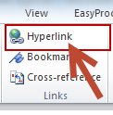
Document properties/metadata
Accurate document properties make it easier to identify and locate information. Go to the File tab and click on the Properties drop-down menu and choose Advanced Properties.
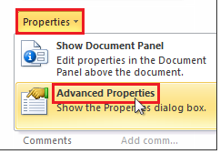
Click on the Summary tab and add information in the Title and Author fields. Add information in additional fields if desired.
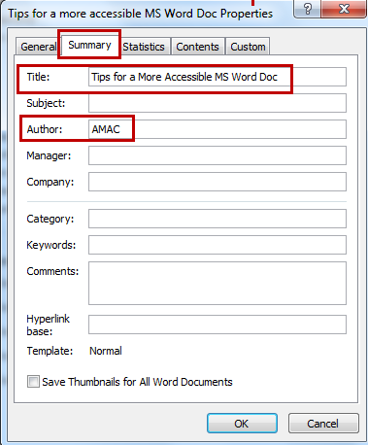
Other Issues
A couple of other topics to keep in mind:
Language
If your document contains more than one language, you can identify that language within the Review Tab on the ribbon. Select the Language options > Set Proofing language.
Color and Color Contrast:
You do not want to use color is the sole indicator of information. It is necessary to use another means of conveying the information, for example do not use the color red as the sole means of identifying required information, you could also include an asterisk and a key denoting which symbols indicate information that is required.
Third party color contrast analyzers can be used to help you evaluate whether the color contrast of your document is appropriate. This is very important for individuals with low vision, but good color contrast improves readability in general.
Also, be sure to use color combinations that are accessible to individuals who are color blind.
Accessibility Checker
Microsoft Word 2010 has a built-in Accessibility Checker that will inspect your document and produce a report noting accessibility errors and warnings such as missing alt text and unclear hyperlinks.
To access the Accessibility Checker, go to File > Prepare for Sharing and click on Check for Issues
From the context menu, choose Check Accessibility
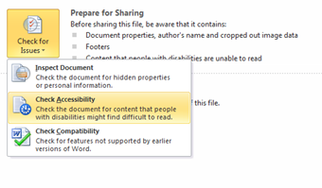
Create accessible PDF from accessible MS Word doc
MS Word 2010 and 2013 include the option to Save and Export accessible formatting including headings and alt text when the doc is saved as a PDF. To export your Word doc to an accessible PDF format, go to File > Save As >
from the Save as type drop down menu choose PDF and click on Options.
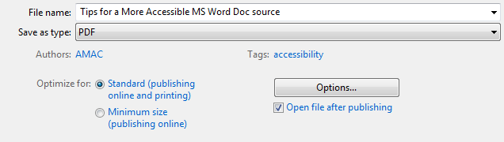
From the PDF Options menu, under Include non-printing information, be sure to check the following options:
Create bookmarks using Headings
Document properties
Document structure tags for accessibility
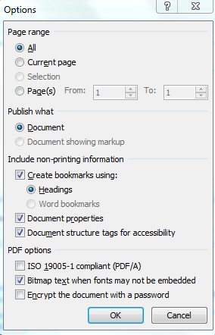
Adobe PDF Maker Add-In for MS Word
When Adobe Acrobat Professional is installed, the Adobe PDF Maker Add-In for MS Word also provides the capability to save the accessible Word Doc as an accessible PDF. The PDF will include Bookmarks for navigation and structure while also retaining other accessibility features including formatted lists and alternative text descriptions. The Adobe PDF Maker will also add tags to the exported PDF which will enhance functionality for screen reader accessibility. (The options described above also add tags for document accessibility).
From the File tab, select, Save as Adobe PDF.
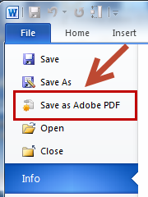
Screenshot showing PDF exported from Word doc with visible bookmarks created from Headings.
