AMAC Orders User Guide

Table of Contents

Signing into AMAC Orders 2
Adding a Student 3
Adding an Order 5
Searching the AMAC Repository 7
Downloading Books 8
Book Quotes and Reports 9
Updating Instution Information 10
Training and Support……………………………………………..11

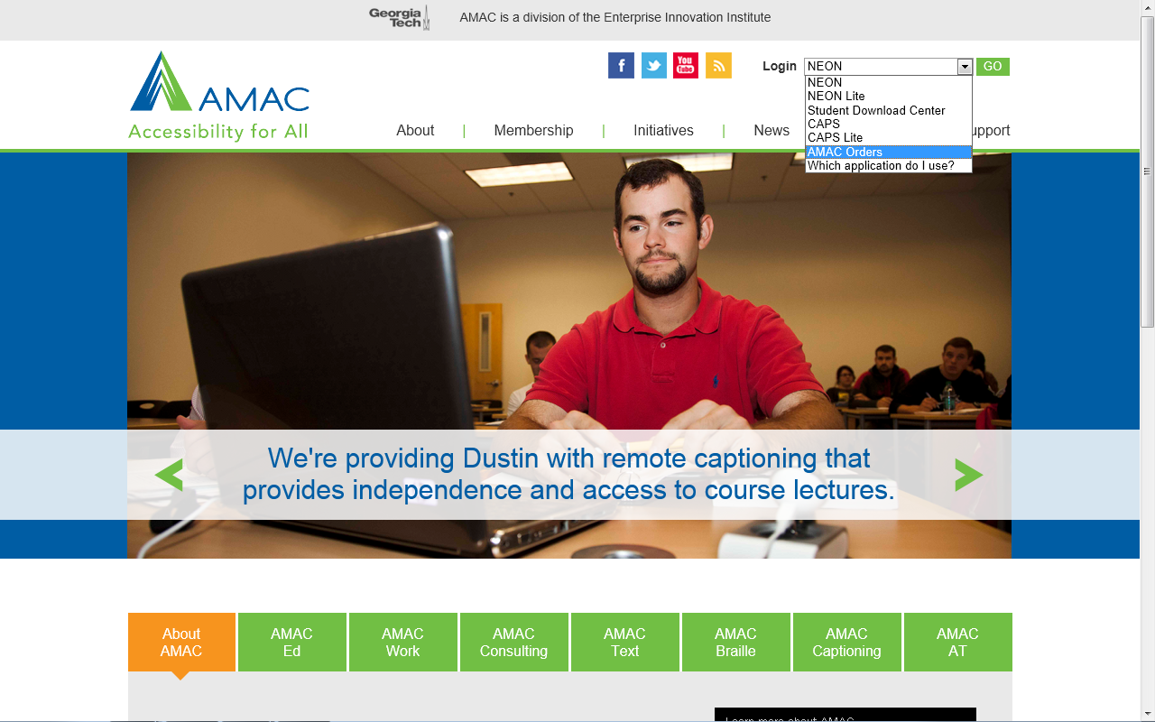
Signing into AMAC Orders

- Go to www.amacusg.org
- Select AMAC Orders under Login section, then press GO
- Login with unique email and password

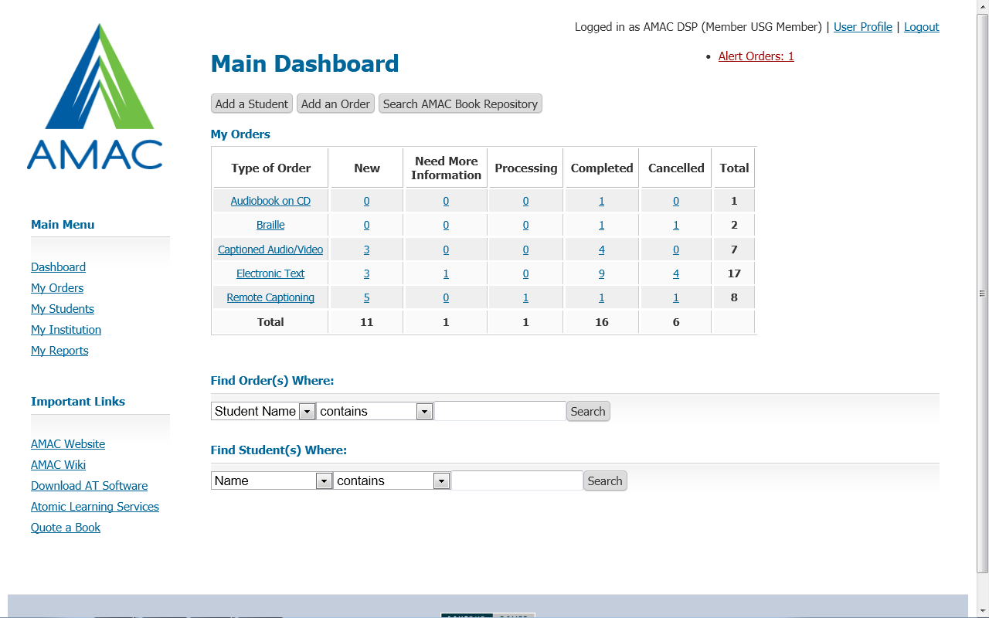
Adding a Student

- Click on Add Student
- Fill out student information
- Fields marked with a red asterisk (*) are required

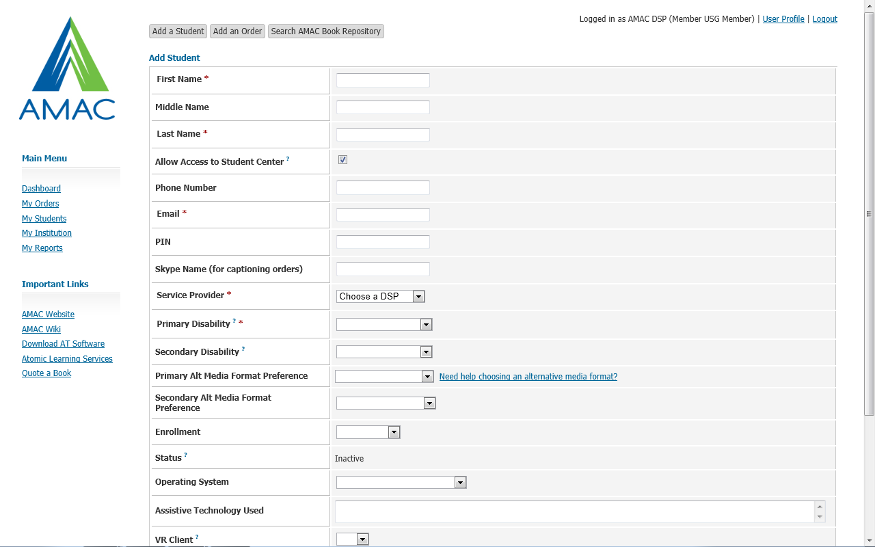
Adding a Student (cont.)

- Uncheck Allow Access Student Center if you do not want student to access books and software themselves
- Email and PIN are used t give student access to Student Download Center
- While not required, specify student’s Primary Alternative Media Preference to remind you later what format each student prefers

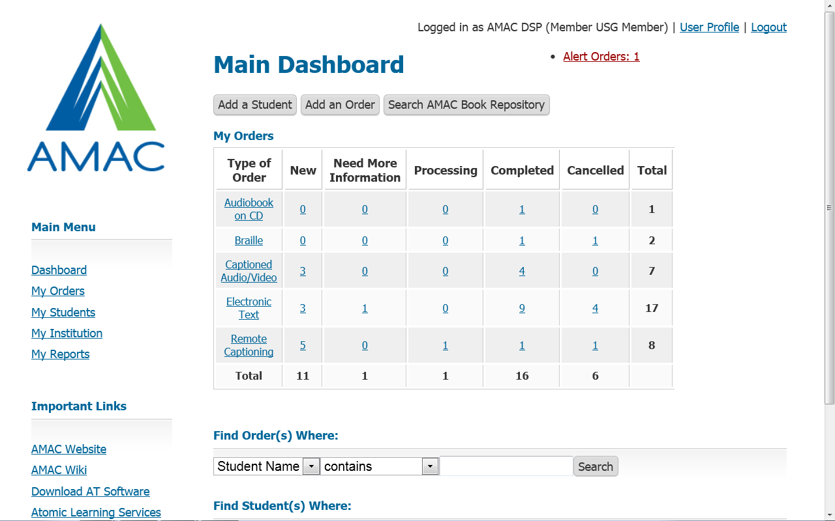

Adding an Order

- Click on Add Order
- Fill out order information
- Fields marked with a red asterisk (*) are required
- Orders that require your attention are listed under Alert Orders in the top right corner of the screen

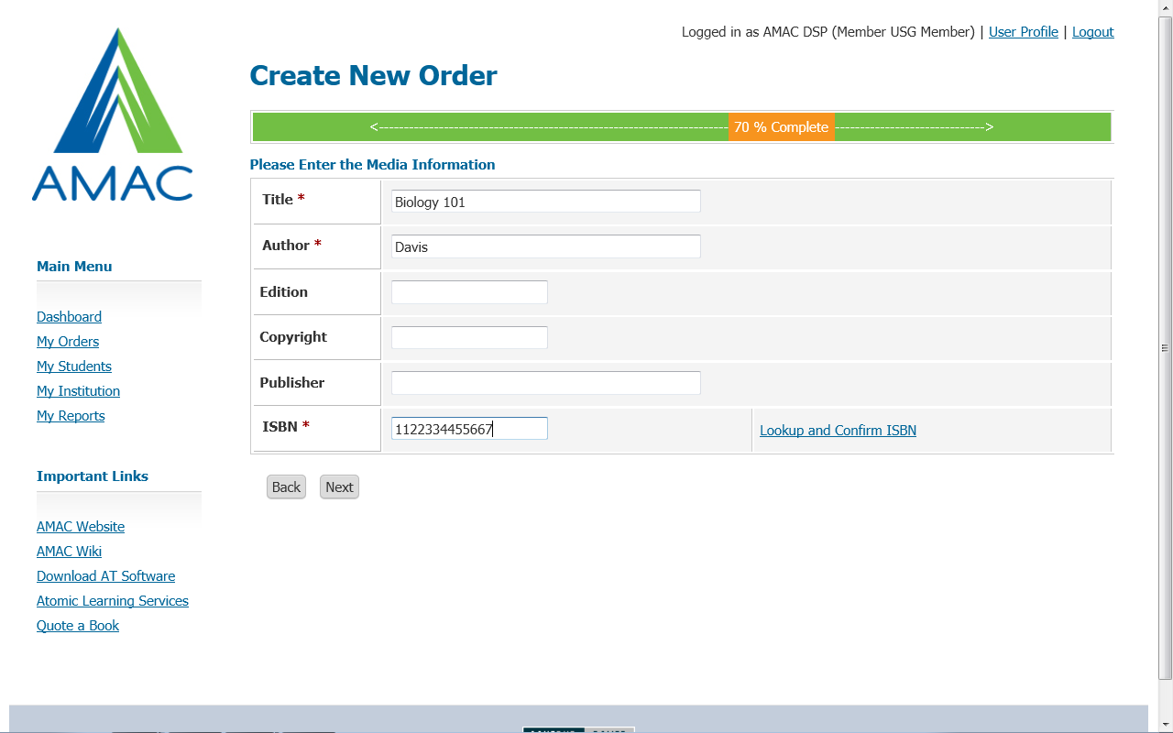
Adding an Order (cont.)
- Select Student ID# and go through the next steps
- Fill in required book information (title, author, etc.)
- Input either 10 or 13 digit ISBN
- Click on link to Look up and Confirm ISBN
- Select Alternative Media Format – if choosing Electronic Text, select Electronic Text Format (PDF, DOC or HTML)
- You can place orders for E-Text, Captioning, and Braille
- Review your Order before hitting submit

Searching the AMAC Repository
- Click on the Search AMAC Book Respository button
- Type in your book’s ISBN, title, or author
- Click on Search
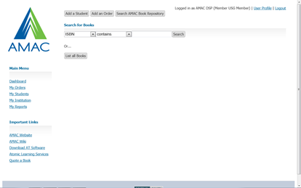
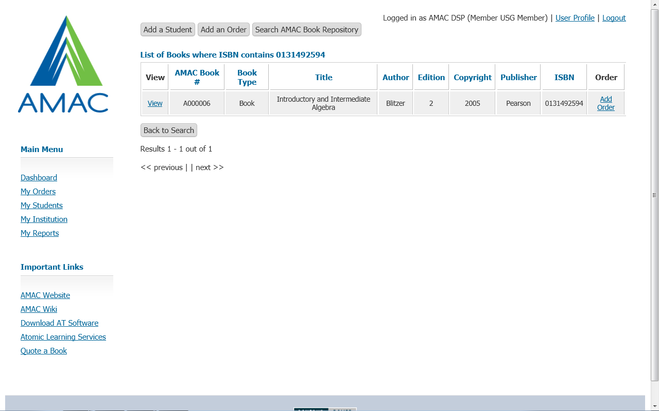
- If correct book is found, click on the Add Order button on right hand side

Downloading Books
- Search for the order using the quick link located on the Main Dashboard
- Click on the View button
- Scroll down to the Downloads section of the order record
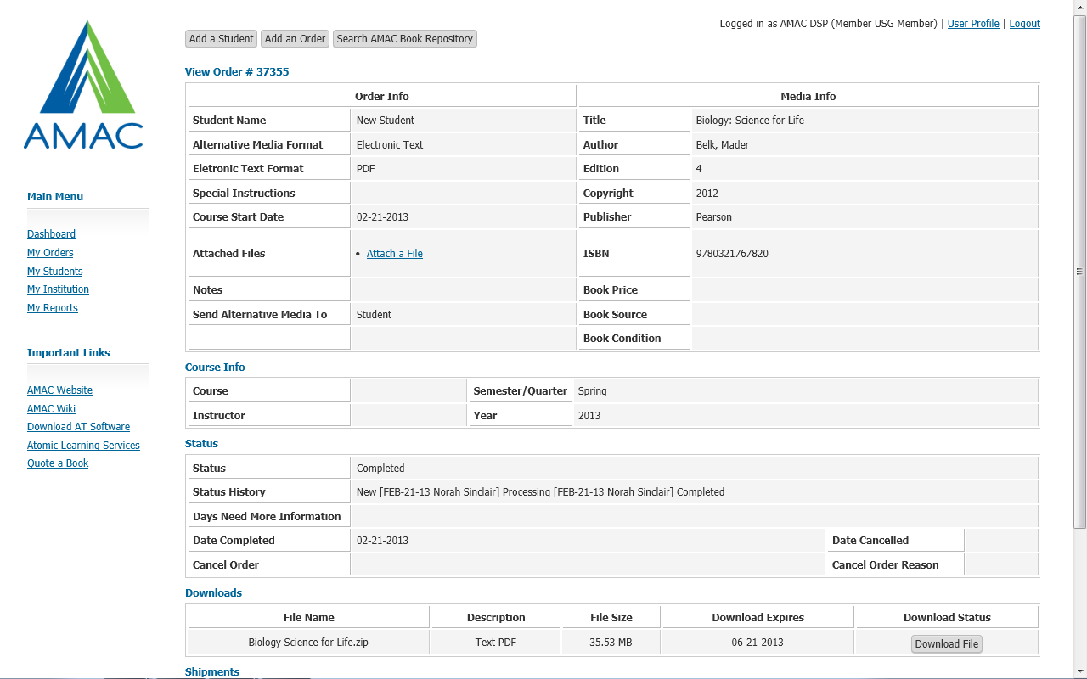
- Click on the Download File button

Book Quotes and Reports
- Click on Quote a Book to estimate a book price based off page count and alternative media format
- Click on My Reports and see a list of commonly requested reports

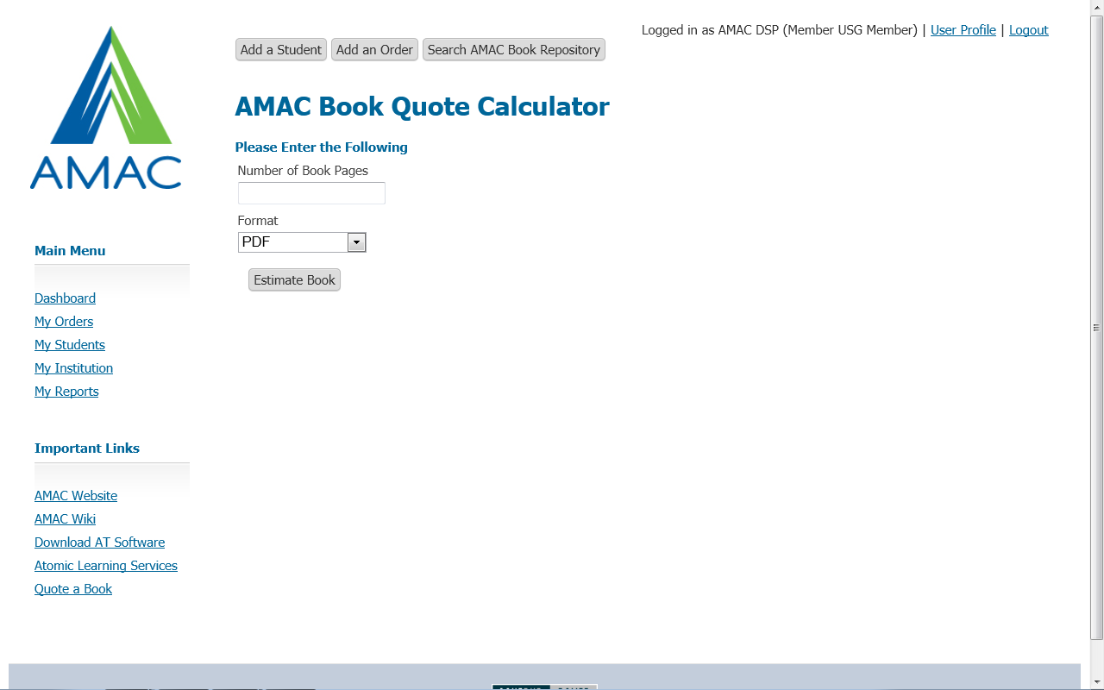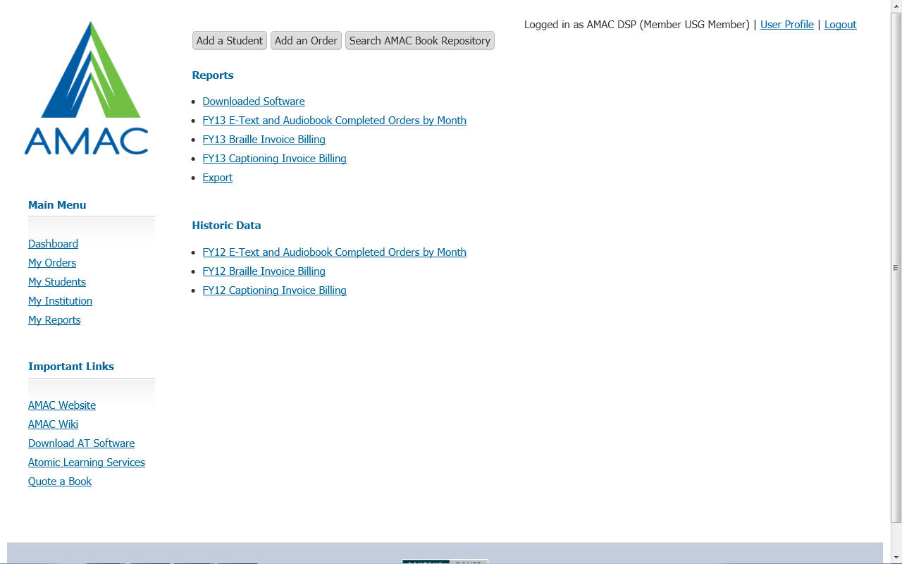

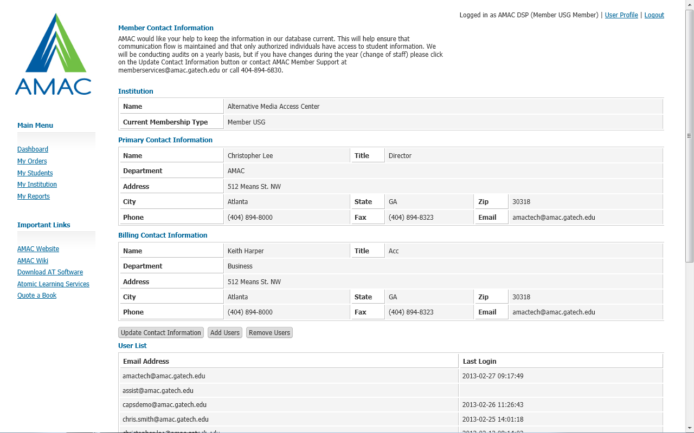

Updating Institution Information
- Click on My Institution on Main Dashboard
- Click to update Contact Information, Add Users, or Remove Users

Training and Support

If you would like additional training, sign up for an AMAC Orders training on the AMAC Events Webpage (www.amacusg.org/events.php)

Email or Call AMAC Technical Support at amactech@amac.gatech.edu; 1-866-418-2750 (M-F 8:30-4:30 EST)

