NEON Lite Training Guide

Table of Contents

Signing into NEON Lite 2
Adding an Order 3
Searching the AMAC Repository 5
Downloading Books 6
Training & Support 7

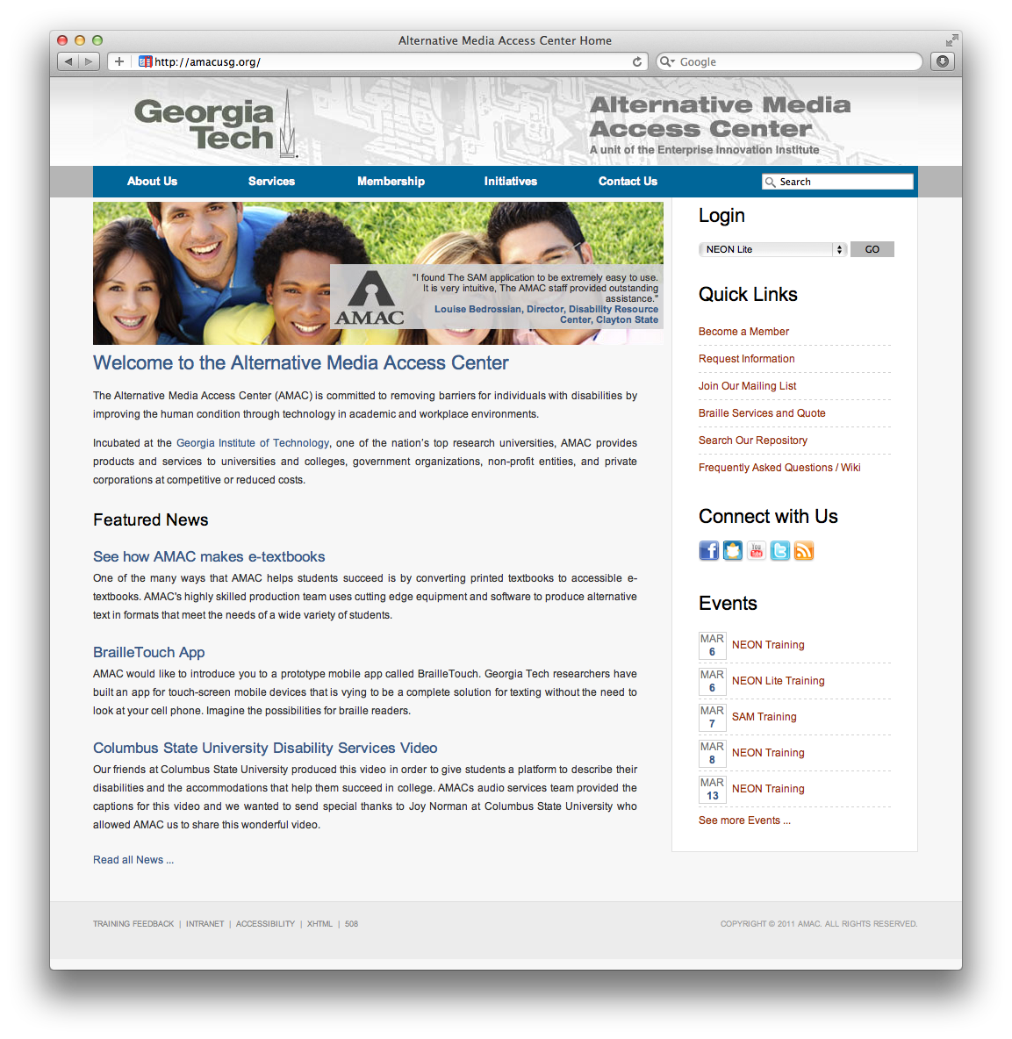
Signing into NEON Lite

- Go to www.amacusg.org
- Select NEON Lite under Login section, then press GO
- Login with unique email and password

Adding an Order
- Click on Add a New Order
- Fill out order information
- Fields marked with asterisk (*) are required
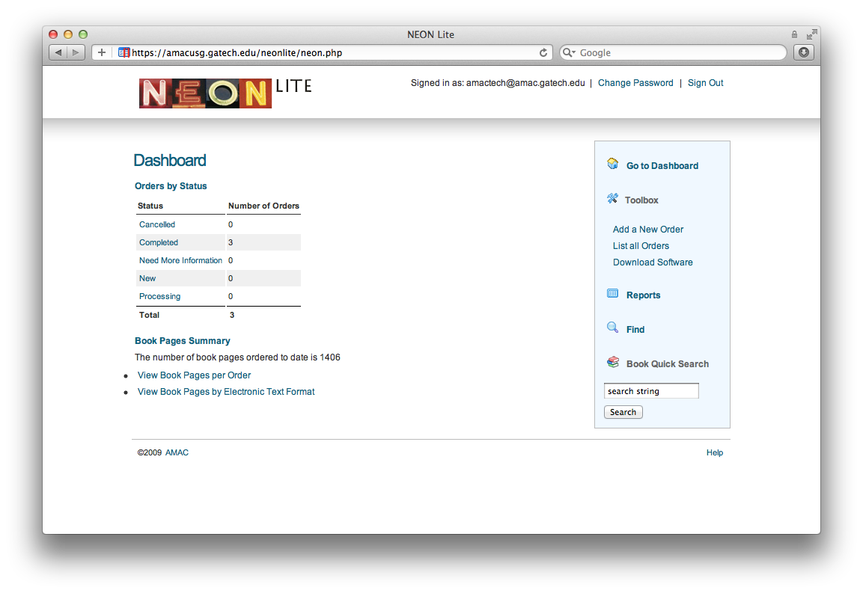

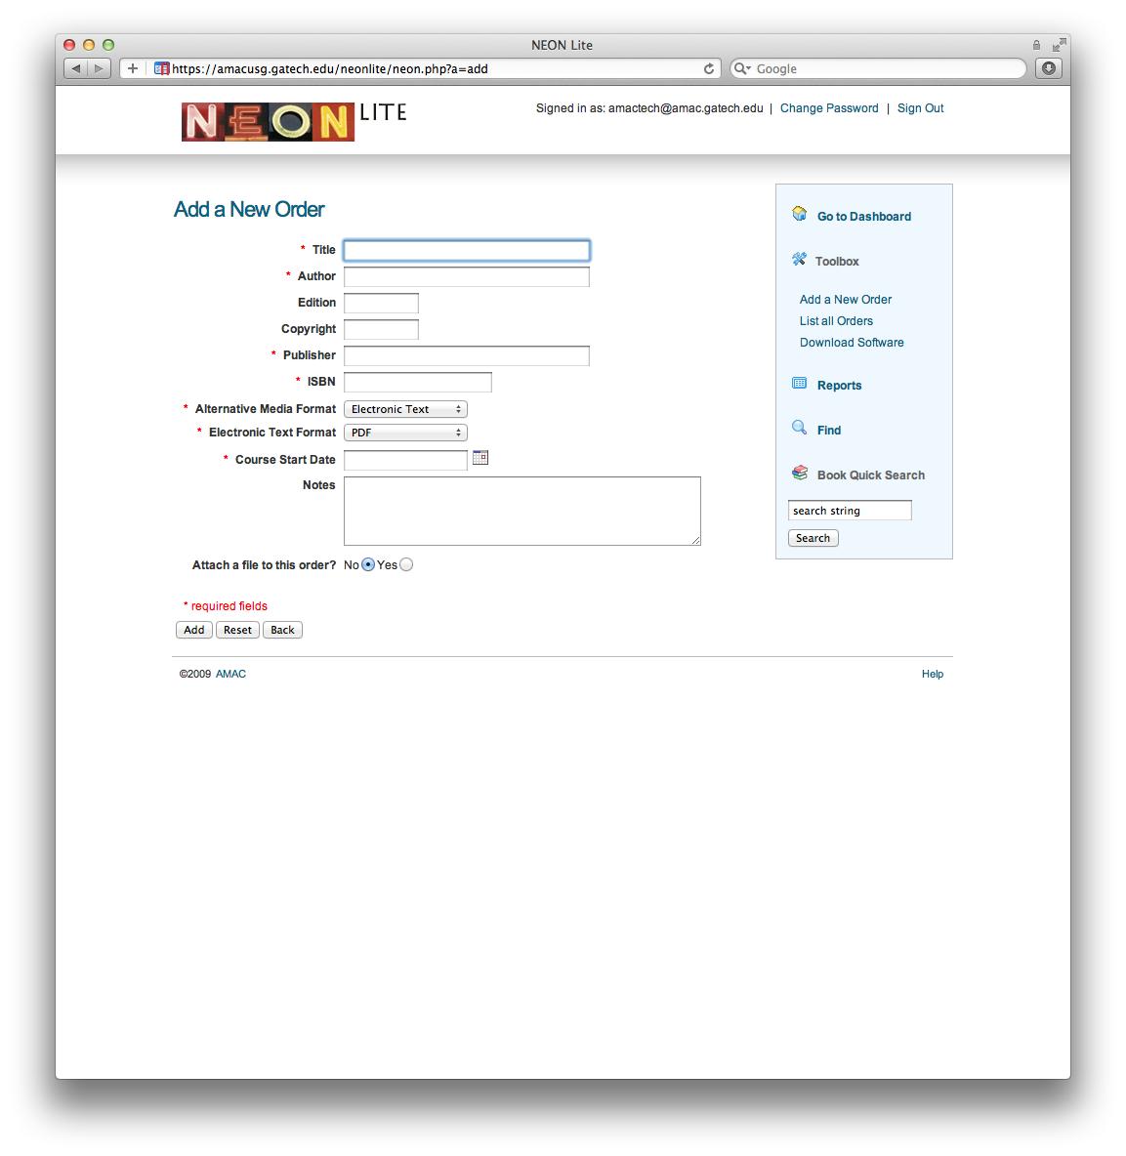
Adding an Order (cont.)
- Fill in required book information (title, author, etc.)
- Input either 10 or 13 digit ISBN
- Select Alternative Media Format

  - If choosing Electronic Text, select Electronic Text Format (pdf or doc)
  - If choosing Braille, select Braille Format Type (book, exam, or supplement)

- Click on Add

Searching the AMAC Repository

- Click in the Book Quick Search text box
- Type in your book’s ISBN, title, or author, then click Search
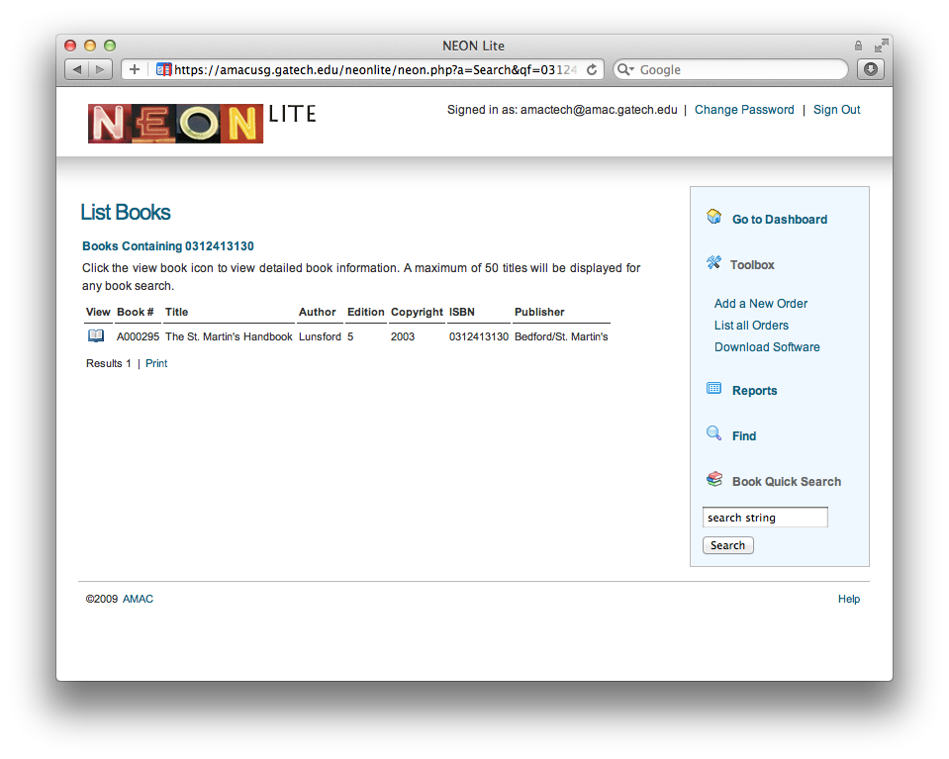
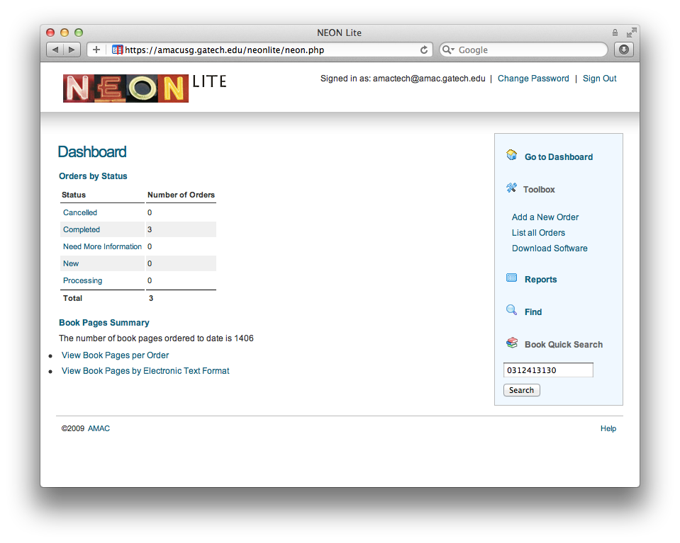
- If correct book is found, click on the Book icon, then select Create Order for this Book
2
1

Downloading Books

- Click on Completed orders on the Dashboard
- Find the order you want to download and click on the View icon
- Scroll down to the Downloads section of the order and click on Download File
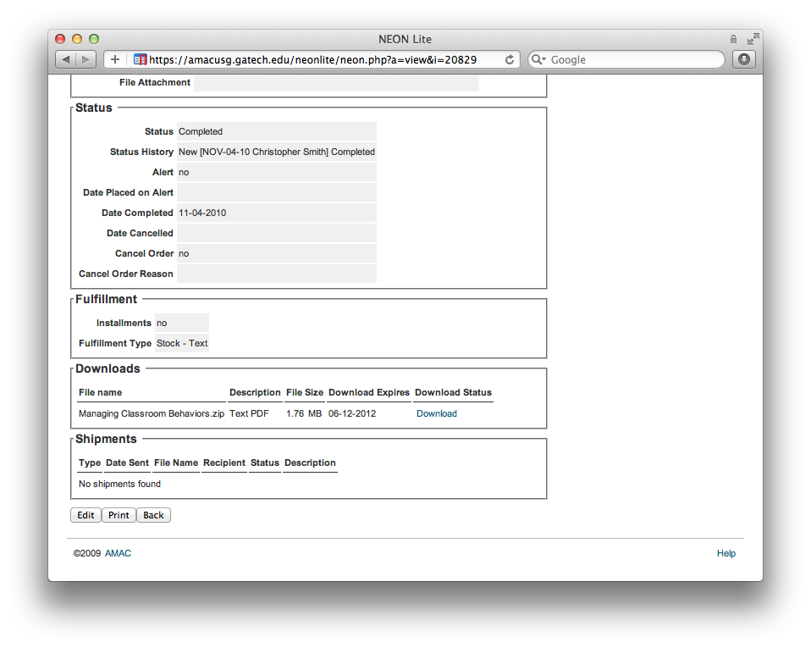
2
1

Training & Support

- Click on the blue Help button on the bottom of the page
- Sign up for weekly NEON Lite Trainings on the AMAC Events Webpage (www.amacusg.org/events.php)
- Email AMAC Technical Support at amactech@amac.gatech.edu
- Call AMAC Technical Support at 1-866-418-2750 (M-F 8:30-4:30 EST)

