Learning Ally Audiobook Manager User Guide

Introduction 2
What is Learning Ally Audiobook Manager? 2
System requirements 2
The Learning Ally BookShelf 2
Searching and ordering books 3
Step 1: Search for books: 3
Step 2: Order books: 3
Learning Ally Audiobook Manager 5
What is Learning Ally Audiobook Manager? 5
Install the Learning Ally Audiobook Manager 7
Using the Learning Ally Audiobook Manager 13
Returning Users 13
Select player 14
Select books 14
Sync books to player 14
Download a book and sync to player 14
Player-specific syncing instructions 15
DAISY Hardware Player 15
DAISY Software/Learning Ally ReadHear 16
Learning Ally Audio App for iOS* 16
Syncing files directly to your computer 16
Play books 17
Configure Settings 18
Change the location of where my Downloads are stored 18
Customize my Internet Settings/Proxy Server 18
Manage Players 18
Advanced Settings 19

Introduction

Welcome to the Learning Ally Audiobook Manager User Guide. This User Guide is designed to help you through your experience in downloading and syncing a Learning Ally book.

What is Learning Ally Audiobook Manager?
The Learning Ally Audiobook Manager is a program you run on your computer to download and sync your Learning Ally books to any Learning Ally authorized player, whether software or hardware.

System requirements
- Windows XP, Vista, Windows 7
- Internet Explorer 7 or higher
- Firefox 3 or higher

The Learning Ally BookShelf
The Learning Ally BookShelf displays all titles you have added to your personal library. You can view the book details or remove a book from your BookShelf.
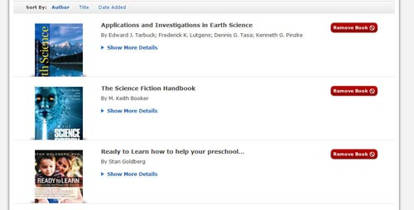
You can search for books in the book catalog. Click the "Add to BookShelf" button to order your book in a downloadable format.

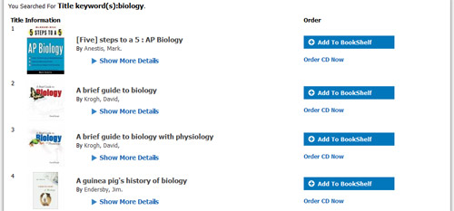

Searching and ordering books
Learning Ally has an extensive searchable book catalog. You can search by:
- Title
- Author
- ISBN number

Step 1: Search for books:
- Log in to your Learning Ally online account.
- Go to the Book Catalog.
- Search for your book by title, author, or ISBN number (for a more detailed search, click "Advanced Search").
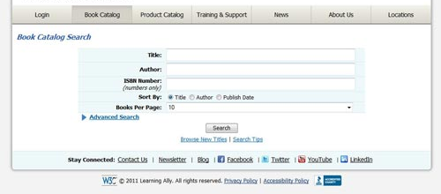

Step 2: Order books:
Once you have located your book in the book catalog:
- Click the "Add to BookShelf" button to order downloadable books.
- Select "Order CD" for DAISY compact discs (if you choose the CD option, you will be directed to a checkout process).
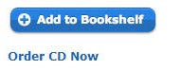
Your selected title will be ordered or added to your BookShelf.
Once you have added the books to your BookShelf, you will need to download and sync your books. Click the "Download & Listen" button to run the Learning Ally Audiobook Manager.

Learning Ally Audiobook Manager

What is Learning Ally Audiobook Manager?
The Learning Ally Audiobook Manager is a program you run on your computer to download and sync your Learning Ally books to your Learning Ally authorized playback devices, whether software or hardware. The program syncs with your online BookShelf so you can easily download and sync titles to your favorite playback devices.
Let’s take a moment to get familiar with the interface:
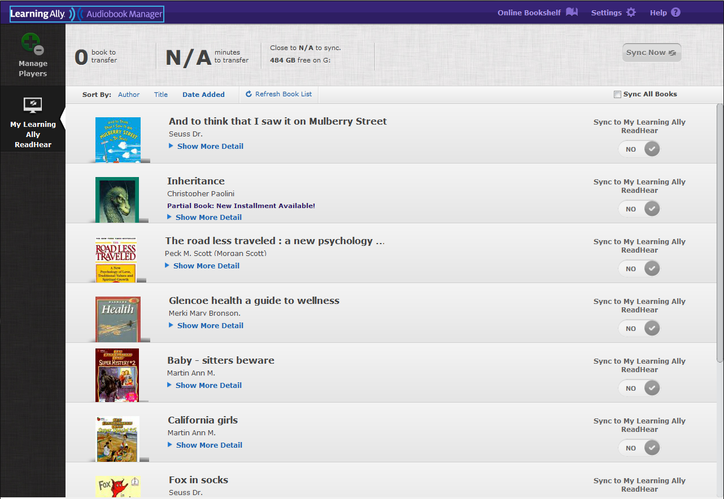
- My BookShelf:
The main area displays the books that have been placed on your online BookShelf. Using the buttons on the right side of the screen, you can select titles to sync to your devices.
You can sort your list of books by Author, Title, and Date Added.
When you order new books through your online BookShelf, click on the Refresh Book List button to update your book listings. Please note that you cannot delete books from this program, but you can delete books from your account through your online BookShelf.
- Summary bar:
The top portion of the screen summarizes the properties of the books you select for transferring to your device, such as number of books selected, total number of minutes it will take to transfer, and file sizes.
- Manage Players bar:
The left side of the screen is dedicated to organizing (and adding) your devices. If you have multiple devices, you can toggle between then to sync books to each individual device in your collection.
- Menu bar:
The very top of the screen includes the Online Bookshelf (your Learning Ally account), Settings and Help buttons. The Online BookShelf button will take you to your online account on LearningAlly.org. Here, you can search, add, and delete books in your BookShelf. In your Settings, you can modify the parameters you set during installation, organize your players, change your default player, and more. The Help button will launch the Learning Ally website to guide you through the program.

Install the Learning Ally Audiobook Manager

You will need to log in to your Learning Ally online account to access the Learning Ally Audiobook Manager. After logging in:
- Go to "My Bookshelf". You can get there from either the navigation bar or the blue button on the welcome screen.
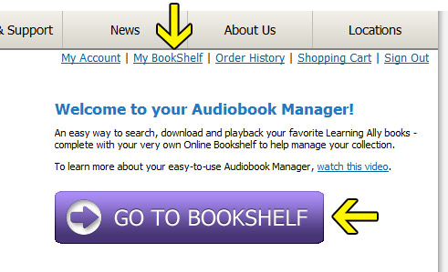
- Click "Download & Listen" to get the Learning Ally Audiobook Manager software
In the event that the automatic installer doesn’t load; you will see a new window with a manual installation link. Download the installation file (about 30 MB in size) and follow the installation wizard prompts.
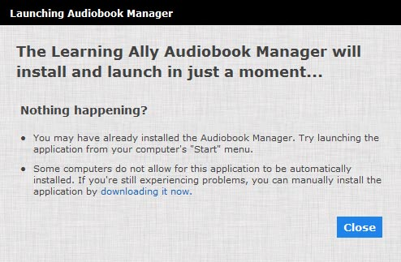
- Once the installation file has finished download, click "Run"
- The Installation Wizard will open. Click “Next”
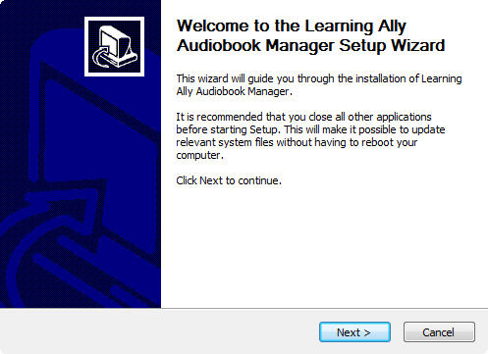
- Agree to the terms of the license agreement. Check “I accept the terms of the License Agreement” and click “Next”
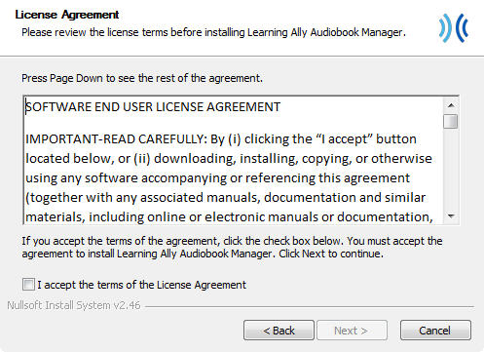
- Keep the default location for installation of the program or select your own location. Click “Next”
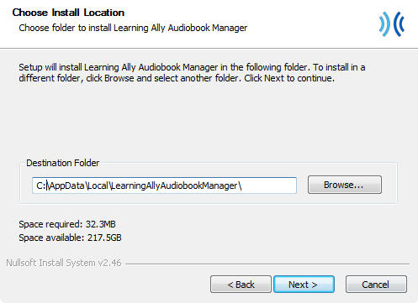
- Keep the default Start Menu folder or choose a Start Menu folder where you'd like to create the program's shortcut. Click “Next”
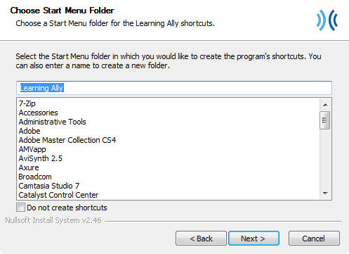
- Enter your proxy setting type. For typical users, we recommend leaving this to "No Proxy." Advanced users may want to select Auto-Detect option or manually enter in proxy settings. If you're using the program in a school setting, you may need to manually enter your proxy server settings.
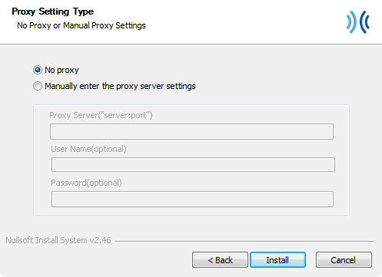
- The program will now install. Click "Finish" to proceed.
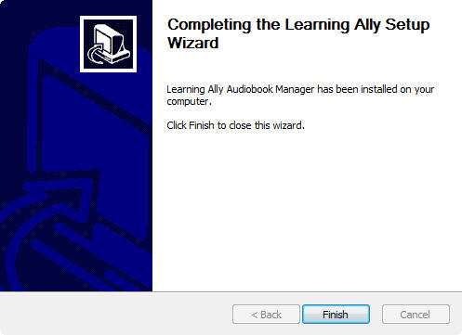
- In the Setup Learning Ally Audiobook Manager window, keep the default download path or you can choose your own path. Click “Next Step”.
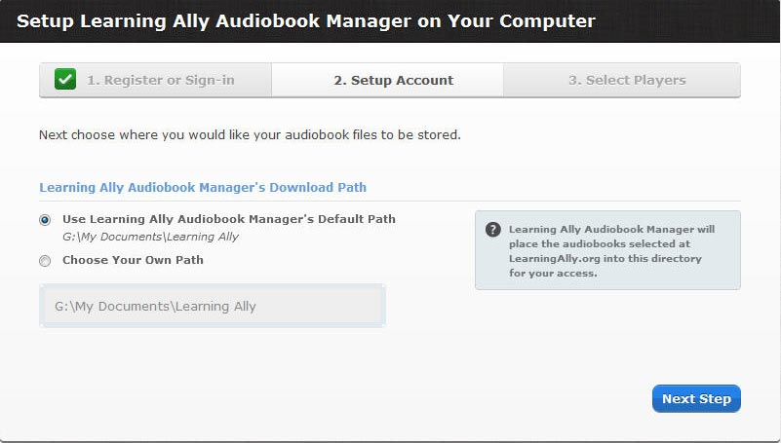
- In the Setup your Audio Player window, you will have to add a default device to the Learning Ally Audiobook Manager. You can choose to add additional playback devices after the Learning Ally Audiobook Manager is completely installed.
There are four basic types of playback options available:
- Learning Ally ReadHear (Must be installed on your computer)
- iOS Devices (iPhone, iPad, iPod touch) (Must have iTunes installed on your computer)
- DAISY playback options
- Manually Manage Your Files
- Click on your playback option and click “Add this Player”
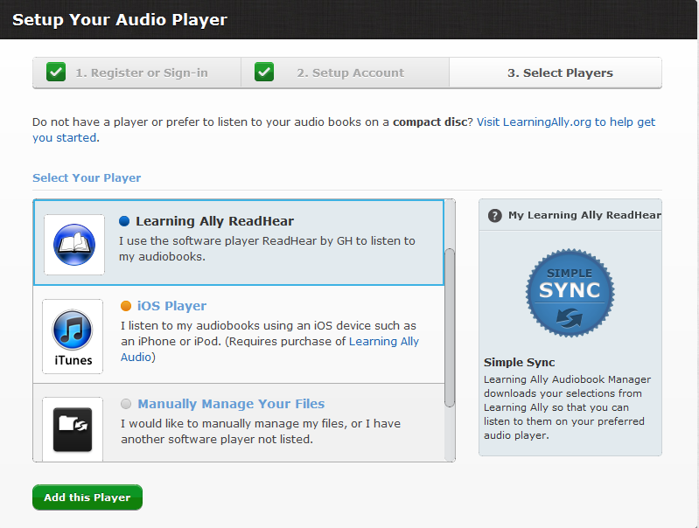

Using the Learning Ally Audiobook Manager

Returning Users
If you have previously downloaded and installed the Learning Ally Audiobook Manager, you can launch the application from your desktop shortcut or list of Program Files on your computer.
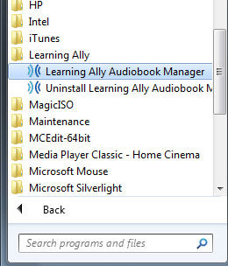
Help
When you launch the Learning Ally Audiobook Manager a Help dialog box will open. You have the option to visit our online help center or listen to an audio tutorial on the Audiobook Manager. To close the Help dialog box, click “Close Now”. If you do want this dialog box to open again, please click “Do not show this dialog again” and click “Close Now”.
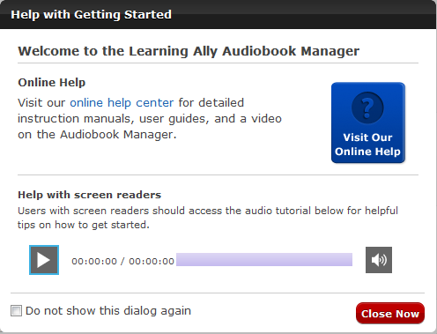

Select player
When you are ready to download and sync your book, simply select a player from the list on the left hand side of your Learning Ally Audiobook Manager.

Select books
From your BookShelf, you can select your desired book and sync it with your player by clicking the toggle switch next to the book from “No” to "Yes".
You can also choose to sync multiple books by clicking the toggle switch next to more than one book or choose to sync all books by checking the “Sync All Books” box at the top of the page.

Sync books to player

Download a book and sync to player
- Click "Sync Now" to begin download process.
- The Learning Ally Audiobook Manager will validate your player.
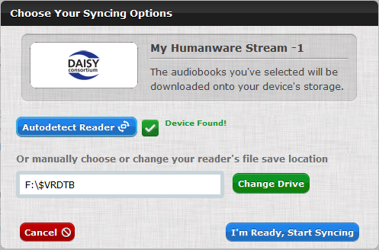
- The Learning Ally Audiobook Manager displays the progress of your download.
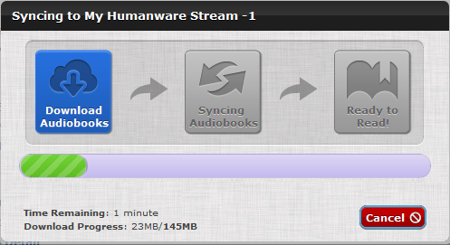
- You will be prompted with further instructions depending on the type of player you are using.

Player-specific syncing instructions

DAISY Hardware Player
- Connect your device.
- Select your book.
- Click “Sync Now”
- Manually choose or change your reader's file save location using the "Change Drive" button. If you use the AutoDetect feature, make sure that the location is accurate before syncing to the device.
- Click "I'm ready, Start syncing".

DAISY Software/Learning Ally ReadHear
Learn more about how to get ReadHear
- Select your book
- Click “Sync Now”
- Files will be downloaded to the default location. If you are using Learning Ally ReadHear by gh for PC, the Learning Ally Audiobook Manager will sync the book to your software's library. Don't have ReadHear? You can download this software for free from your Learning Ally account.
- After download, you can open your book using your software’s “Open book” command.
- If you don’t know where the books downloaded, you can use the “show book folder” command.

Learning Ally Audio App for iOS*
Learn more about the Learning Ally Audio app
- Select your book
- Click “Sync Now”
- Files will be downloaded to the default location.
- After download, you will be prompted to launch iTunes. Click “Launch iTunes”.
- Read instructions on how to manually transfer your book to your iPad, iPhone or iPod touch.
Download the guide in PDF format
Download the guide in Word format
* Purchase of Learning Ally Audio app ($19.99) is required in order to play Learning Ally audiobooks on iOS devices.

Syncing files directly to your computer
- Select your book
- Click “Sync Now”
- Your files will be saved to the default location. If you want to change that location now, click "Change Drive".
- Click "I'm ready, Start syncing".

Play books
Once you have chosen a book and the sync completed, the Learning Ally Audiobook Manager will instruct you on what to do next depending on your specified playback device. Player-specific syncing instructions.
Get help using your playback devices on LearningAlly.org.

Configure Settings

Change the location of where my Downloads are stored
By default, the Learning Ally downloads are stored in the following locations:
- For Windows XP: My Documents/Learning Ally
- For Windows Vista and 7: Documents/Learning Ally
You can change the download location by selecting or creating a unique folder to store the downloads by clicking on the "Settings" button in the Learning Ally Audiobook Manager, and then clicking on the "General Settings" tab.
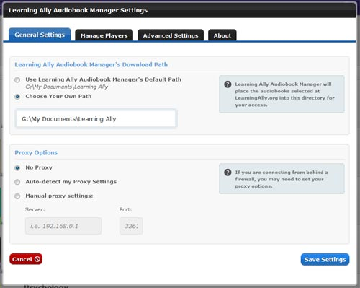

Customize my Internet Settings/Proxy Server
If you use a proxy to connect to the Internet, you can configure that under the "General Settings" tab. Try the “Auto-detect” option first. If this doesn’t work, try entering your proxy manually.

Manage Players
You can add or remove a player, edit a player’s nickname or change a default player under “Manage Players”.
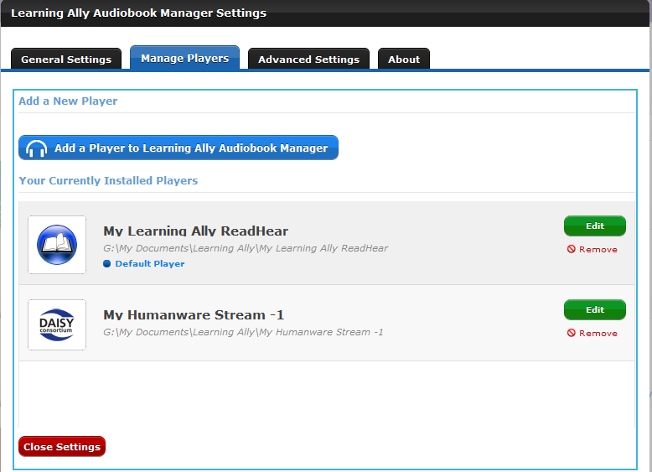

Advanced Settings
The "Advanced Settings" tab gives you a few more options for managing your books. You can purge your cache of downloaded books, and view your syncing and downloading history.
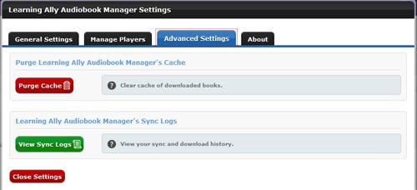

Troubleshooting

Login

Q. I logged into the Learning Ally Audiobook Manager and I received the error message “The password supplied is not valid”

A. Please verify that you are typing in the correct password. Learning Ally passwords are case sensitive. If you need help recalling your password, please visit Forgot password or call 1-800-221-4792.

Bookshelf

Q. My book is listed on the bookshelf in my Learning Ally Audiobook Manager, but it is not ready for download. It gives a date that the book will be available for download.

A. Your book needs to be uploaded to our server. It takes 24-48 hours for the book to be uploaded and you will receive an email when the book is ready for download.

Q. I added a book to My BookShelf, but I do not see it listed on the bookshelf in my Learning Ally Audiobook Manager.

A. Please click “Refresh Book List” in the Learning Ally Audiobook Manager. You should now see your title on the bookshelf.

Download

Q. I received the error “Failed Sync-Network Connection Error” when downloading my book.

A. Please check that you are properly connected to the internet and try the download again.

If you are a school downloading, please check that you have input your Proxy settings into the Learning Ally Audiobook Manager in Settings General Settings.

Q. I received the error “Failed Sync -File System Error: not enough privileges to write to the player (1131)” when downloading my book.

A. Please check the location that your download is going to and verify that you do have permission to download to that location. Also, check that you have enough free space to download to that location.

Q. I’m downloading a new installment of my book and the Audiobook Manager keeps downloading the old installment.

A. Remove the book from your online BookShelf and re-add it. In the Learning Ally Audiobook Manager go to Settings Advanced Settings and click “Purge Cache”. Then try the download again.

