AMAC Orders User Guide

Table of Contents

Signing into AMAC Orders 2
Adding a Student 3
Adding an Order 4
Searching the AMAC Repository 7
Downloading Books 8
Book Quotes and Reports 9
Updating Insitution Information 10
Training and Support……………………………………………..11

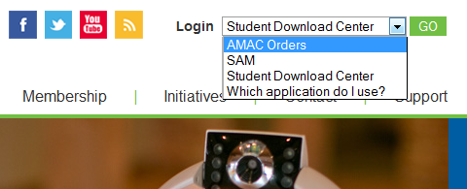
Signing into AMAC Orders

- Go to www.amacusg.org
- Select AMAC Orders under Login section, then click GO
- Login with your email address and password

Adding a Student
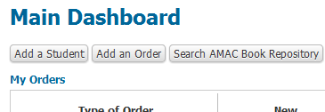
- Click the Add Student button
- Fill out student information
- Fields marked with a red asterisk (*) are required

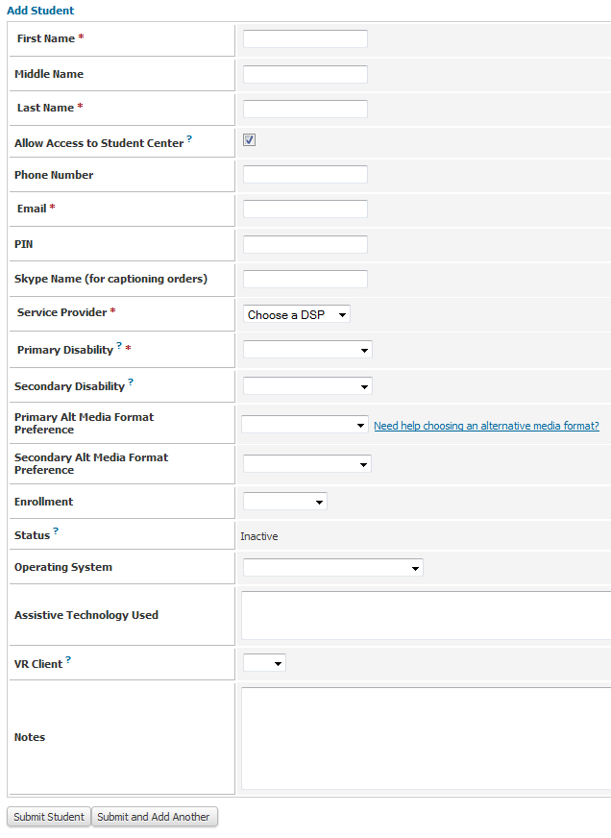
Adding a Student (cont.)
- By default Allow Access Student Center is checked
  - Uncheck if you do not want student to
access books and software themselves
- Email and PIN are used to give student access
to the Student Download Center
- While not required, specify student’s Primary
Alternative Media Preference to remind you
later what format each student prefers
- Click Submit Student or
Submit and Add Another to save

Adding an Order

- Click on Add Order at the top of the screen
- Fill out order information
- Fields marked with a red asterisk (*) are required
- Orders that require your attention are listed under Alert Orders in the top right corner of the screen

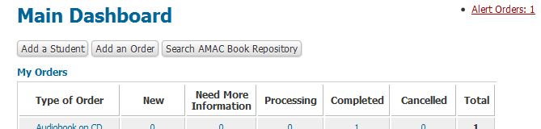

Adding an Order (cont.)
- Select Student ID# and go through the next steps
  - Choose alternate media format, etc.
  - You can place orders for E-text, Captioning, and Braille
- Fill in required information (title, author, etc.)
- Input either 10 or 13 digit ISBN if ordering a Book
- Review your Order before clicking Submit
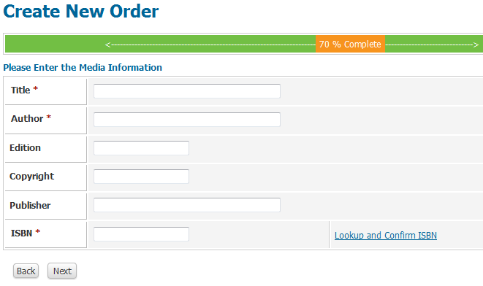

Searching the AMAC Repository
- Click on the Search AMAC Book Respository button
- Search by the book’s ISBN, title, or author
- If correct book is found, click on the Add Order link to the right of the order information
  - If not found, click on Add an Order button at the top of the screen
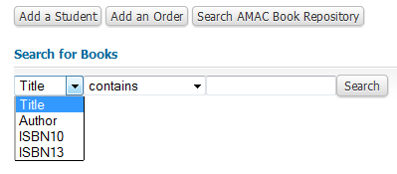

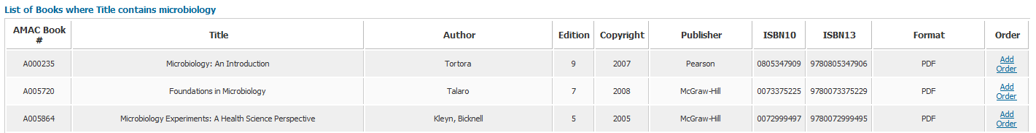

Downloading Books
- Search for the order using the quick link located on the Main Dashboard or click My Orders on left side menu
- Click on the View button
- Scroll down to the Downloads section of the order record
- Click on the Download File button in the bottom right of the screen
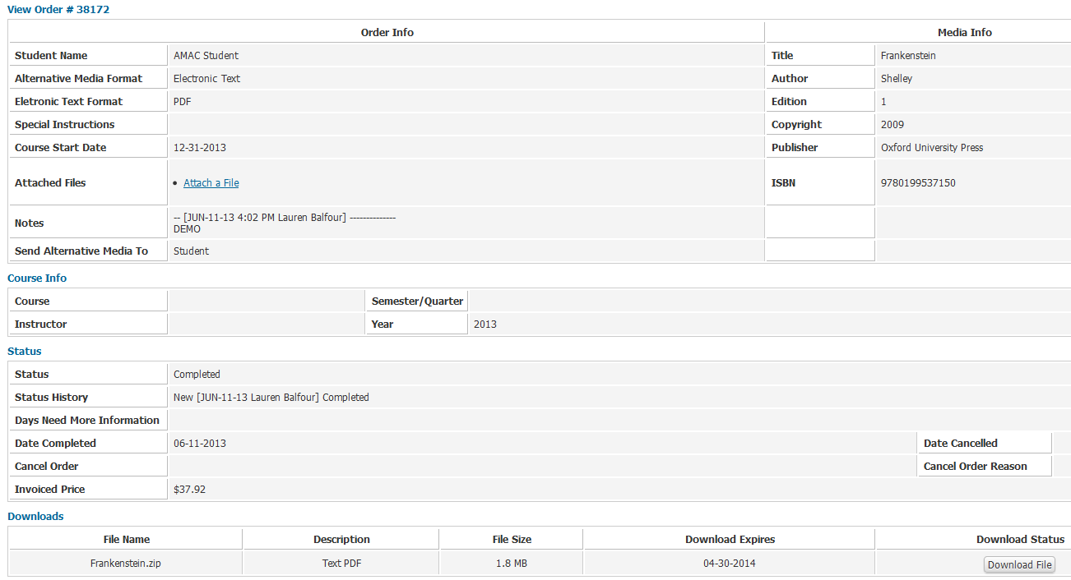

Book Quotes and Reports

- Click on Estimate Book Cost under Important Links to estimate a book price based off page count and alternative media format
- Click on My Reports under Main Menu to access a list of commonly requested reports
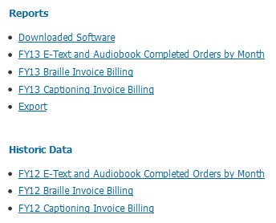
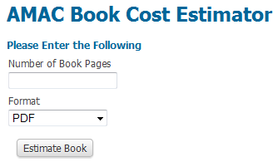

Updating Institution Information

- Click on My Institution on Main Dashboard
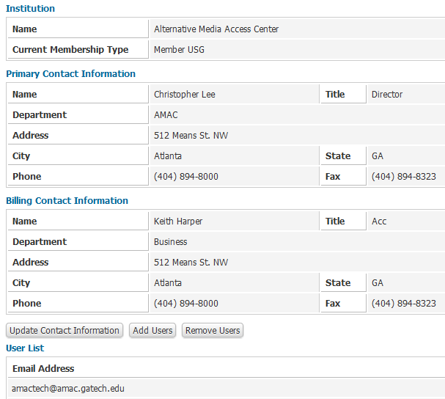
- Click Update Contact Information, Add Users, or Remove Users button

Training and Support

- If you would like additional training, sign up for an AMAC Orders training on the AMAC Events webpage (www.amacusg.org/events.php)
- Email or call AMAC Technical Support at amactech@amac.gatech.edu; 1-866-418-2750 (M-F 8:30-4:30 EST)

