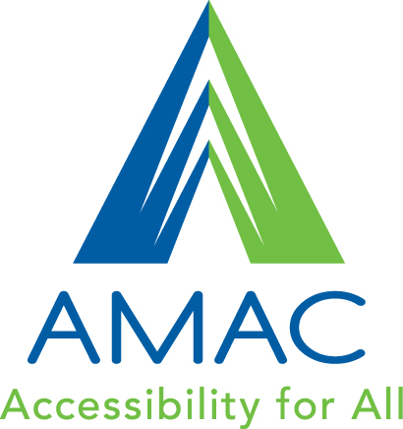

Student Guide
Downloading Books and Software

Technical Support

Online
www.amacusg.org/wiki

Email
amactech@amac.gatech.edu

Phone
8:30 am until 4:30 pm Monday-Friday

Table of Contents
Introducing AMAC 4

AMAC Textbooks 5
How do I order books from AMAC? 5
What book format is best for me? 5
Format/File Types 5

Student Download Center 6
How will I get my Books? 6
How do I unzip a file? 6

Reading Technology 7
How do I download and install reading software? 7
How do I listen to my Audio on CD book? 7

Introducing AMAC

What is AMAC?
AMAC produces and distributes accessible textbooks, media and assistive technology for students who need their textbooks in an alternative format. Technical support for downloading and using books and software is also provided. AMAC is dedicated to providing students with high quality material in a timely manner. Be advised that some formats may take longer to produce than others.

Is AMAC for every student in college?
No. AMAC is only for students with print-related disabilities. Print-related disabilities can be learning differences, visual impairments, blindness or physical challenges, e.g., turning a page or holding a book.

What is alternative media?
Alternative media is printed materials, such as textbooks, converted to a format other than a traditional hard copy. Examples of alternative media include electronic text (e-text), braille, audio files, closed captioning, accessible web sites and tactile graphics. Alternative media formats often require assistive technologies to access.

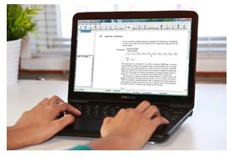

What is assistive technology?
Assistive technology is any piece of software or equipment that helps to increase productivity in school, work and/or the social environment, such as a spell checker, a grammar checker, or software that reads aloud what is on your computer.

AMAC Textbooks

How do I order books from AMAC?
- First, you will need to go to your disability service provider (DSP) and provide the title, author, and ISBN’s of your books. This information can be found in your syllabus or the inside cover of your book.
- Next, you will need to bring the receipts and/or proof of purchase of your books to your DSP.
- Then, your DSP will order your books from the AMAC on-line system.

What book format is best for me?
AMAC provides materials in different formats based on the needs of the student, the content being converted and the availability of the format.

Format/File Types
PDF Format
This format retains the look of the original book page including columns and image location. Chapters are bookmarked for easy navigation. It also allows for text-to-speech software to read the text aloud by a computer. These are best for students who have access to a computer and have trouble visually processing text, writing notes, or highlighting text.

DOC Format (Microsoft Word Document):
This format realigns the text into a single column. Headings are added for navigation, and images include alternative text descriptions. It allows for text-to-speech software to read the text aloud by a computer, in particular screen-readers such as JAWS.

Audio on CD
These CDs are produced by Learning Ally and contain only audio, which has been recorded by volunteers (human narration). They can be played back with software available from the Student Download Center or specialized playback devices. CDs are sent by mail to your DSP’s office. These are best for students who have experience using playback devices, have a visual impairment, and have sufficient and reliable hearing.
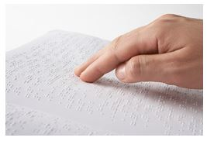
Embossed Braille
These pages employ embossed dots evenly arranged in quadrangular letter spaces or cells, allowing touch reading for the blind. These are best for students who can read braille and who are blind or whose eyesight isn’t sufficient for reading printed material.

Student Download Center

How will I get my Books?
You can download your electronic books from
AMAC’s Student Download Center online (www.amacusg.org/studentcenter.php). You will receive an email notifying you when your book is ready to be downloaded - the subject line of the email will be: AMAC Book Order Complete.

To login:
- Follow the link in the email to the Student Download Center
- Enter your Email and PIN (provided)
- Click Login

After entering the Student Download Center
- Click on the My Orders tab at the top
- Under the Completed section, click on the Download button next to the title
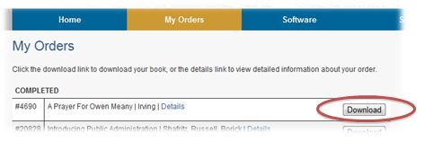
- Your book will download automatically

How do I unzip a file?
All books are sent zipped (.zip), so you will need to unzip the file after download.
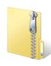
- Navigate to the file you just downloaded
- Right-click on the icon (it should look like this)
- Select Extract All on the pop-up menu
- Follow the short on-screen wizard

*If you are using a Mac, your book will un-zip automatically

Reading Technology

How do I download and install reading software?
You will need to install software in order for the computer to read your books – you can download software for FREE from the Student Download Center.

Note: these programs can only be installed on computers owned by you or your parents.
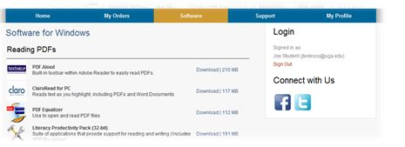

After entering the Student Download Center
- Click on the Software tab at the top
- You will see a list of software, organized by:
  - Reading PDF’s
  - Reading Word Doc’s
  - Listening to Audio on CD
- Select the software you’d like to use, and click on the Download button
- After reviewing the Terms & Conditions, click on the Agree and Download button
- Your software will download automatically

How do I listen to my Audio on CD book?
Learning Ally CD’s can be played using Readhear by gh, which can be downloaded from the Student Download Center.

To register and use the software, please use the following:
- Login Name: amac
- Password: activate

AMAC | Georgia Institute of Technology | Enterprise Innovation Institute
512 Means St., Suite 250 | Atlanta, GA 30318 | www.amacusg.org

